# Generated QA Summary

--- Entry for custom_id: d5c4b87e0dba11ecb1e81171463288e9 ---

Image Source 1 -



Caption for image source 1: Frangipani flowers Frangipani (Plumeria) flowers in Perth, Western Australia.

Example Question - "What color is the center part of a Frangipani flower?"

Example Answer - "The center part of a Frangipani flower is yellow."

Additional Text Source 1 - One of the heavenly damsels in the frescoes of the fifth-century rock fortress Sigiriya holds a 5-petalled flower in her right hand that is indistinguishable from plumeria. In Eastern Africa, frangipani are sometimes referred to in Swahili love poems. (from: Plumeria)

Generated Question - How does the cultural significance of the Frangipani flower in Eastern Africa relate to its depiction in ancient Sigiriya frescoes?

Generated Answer - Both show the Frangipani flower as a symbol of beauty and love in cultural art and poetry.

--- Entry for custom_id: d5bf37a00dba11ecb1e81171463288e9 ---

Image Source 1 -

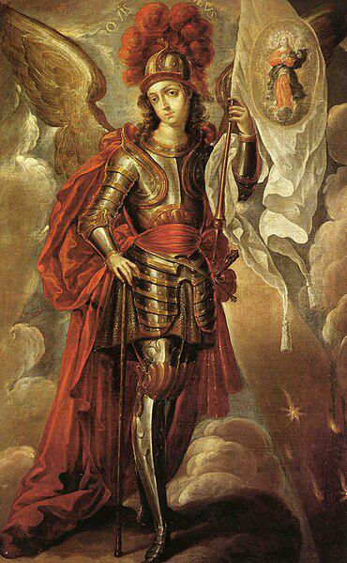

Caption for image source 1: San Miguel Arcángel - Cristóbal de Villalpando Saint Michael the Archangel.

Image Source 2 -

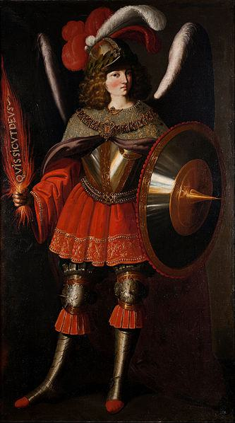

Caption for image source 2: Francisco de Zurbarán and Studio - The Archangel Michael - Google Art Project.

Example Question - "Saint Michael the Archangel's helmet had longer plumage on which painting: The Archangel Michael or Saint Michael the Archangel?"

Example Answer - "The Archangel Michael had longer plumage."

Additional Text Source 1 - In the 4th century, Saint Basil the Great's homily (De Angelis) placed Saint Michael over all the angels. He was called "Archangel" because he heralds other angels, the title Ἀρχαγγέλος (archangelos) being used of him in Jude 1:9. (from: Michael (archangel))

Generated Question - Considering Saint Michael's role as "Archangel," which painting shows him holding a banner that might symbolize his leadership?

Generated Answer - Saint Michael the Archangel by Cristóbal de Villalpando holds a banner, symbolizing his leadership.

--- Entry for custom_id: d5cc89be0dba11ecb1e81171463288e9 ---

Image Source 1 -

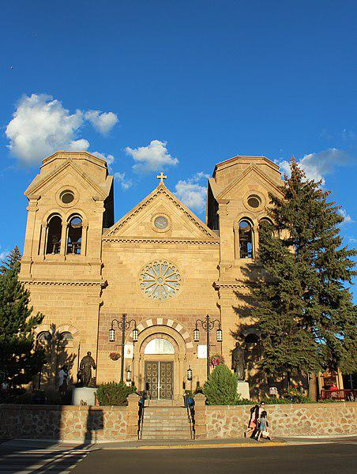

Caption for image source 1: Santa Fe, New Mexico, USA - Cathedral Basilica of St. Francis of Assisi - panoramio.

Image Source 2 -

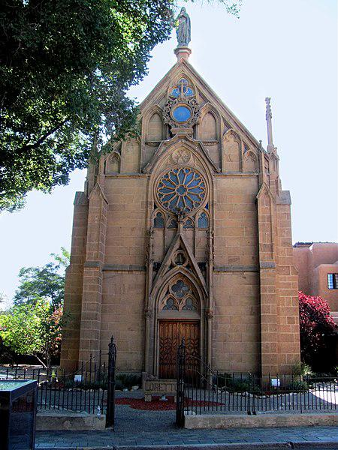

Caption for image source 2: Santa Fe, New Mexico, USA - Loretto Chapel - panoramio (1).

Example Question - "When it comes to the form of window on their facades, what do the Loretto Chapel and the Cathedral Basilica of St. Francis of Assisi have in common?"

Example Answer - "When it comes to the form of window on their facades, the Loretto Chapel and the Cathedral Basilica of St. Francis of Assisi have rose windows in common."

Additional Text Source 1 - In 1986, Pope John Paul II recited the prayer in bidding farewell to the global religious leaders he hosted for the first "World Day of Prayer for Peace", in Assisi at the Basilica of St. Francis. (from: Prayer of Saint Francis)

Generated Question - Which building is connected to the prayer recited by Pope John Paul II during the first "World Day of Prayer for Peace"?

Generated Answer - The Cathedral Basilica of St. Francis of Assisi is connected to the prayer recited by Pope John Paul II.

--- Entry for custom_id: d5cb1d860dba11ecb1e81171463288e9 ---

Image Source 1 -

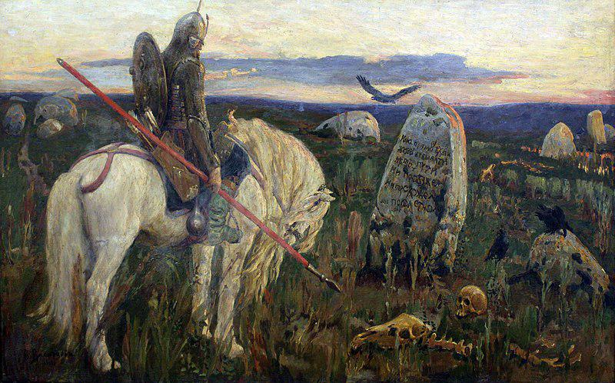

Caption for image source 1: 1919 Vasnetsov Ritter an der Kreuzung anagoria Viktor Mikhailovich Vasnetsov A knight at the crossroads.

Example Question - "What kind of weapon does the horse rider have in his hand in A Knight at the Crossroads?"

Example Answer - "The horse rider has a spear in his hand."

Additional Text Source 1 - Daredevil, who has been possessed by The Hand, hires Profile to take down Moon Knight. During an assault on the Shadowland fortress with Iron Fist, Ghost Rider, Spider-Man, Luke Cage, and Elektra, Daredevil almost kills Moon Knight, but Khonshu appears and asks him to spare his life. (from: Moon Knight)

Generated Question - Does the knight in "A Knight at the Crossroads" hold a weapon similar to those used by the heroes in the Moon Knight story?

Generated Answer - No, the knight holds a spear, unlike the modern weapons used by Moon Knight and others.

--- Entry for custom_id: d5ca078e0dba11ecb1e81171463288e9 ---

Image Source 1 -



Caption for image source 1: Spaltblättlinge.

Example Question - "Is the Spaltblättlinge shaped as a shell?"

Example Answer - "Yes, the Spaltblättlinge is shell-shaped."

Generated Question - Do the Spaltblättlinge mushrooms grow on wood and have a fan-like shape?

Generated Answer - Yes, they grow on wood and have a fan-like shape.

--- Entry for custom_id: d5c605800dba11ecb1e81171463288e9 ---

Image Source 1 -

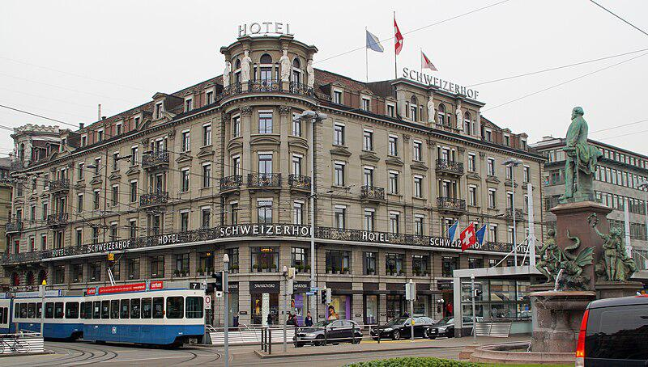

Caption for image source 1: 2015-03-25 Bahnhofplatz7 This photo was taken by Robert Kropf (User:TheRunnerUp) and released under the license CC BY-SA 4.0..

Example Question - "How many statues are on the Schweizerhof Hotel in Bahnhofplatz?"

Example Answer - "There are 6 statues on the roof of the Schweizerhof Hotel in Bahnhofplatz."

Additional Text Source 1 - It was awarded as the "historical hotel of the year" in 2012 by ICOMOS. He also designed the Cresta Palace Hotel in Celerina (St. Moritz), the Schweizerhof Hotel in Como and the former Hotel Reber au Lac in Locarno. (from: Jost Franz Huwyler-Boller)

Generated Question - Is the Schweizerhof Hotel in Bahnhofplatz recognized for its historical significance like the other hotels designed by Jost Franz Huwyler-Boller?

Generated Answer - Yes, the Schweizerhof Hotel in Bahnhofplatz was awarded "historical hotel of the year" in 2012.

--- Entry for custom_id: d5c44d440dba11ecb1e81171463288e9 ---

Image Source 1 -

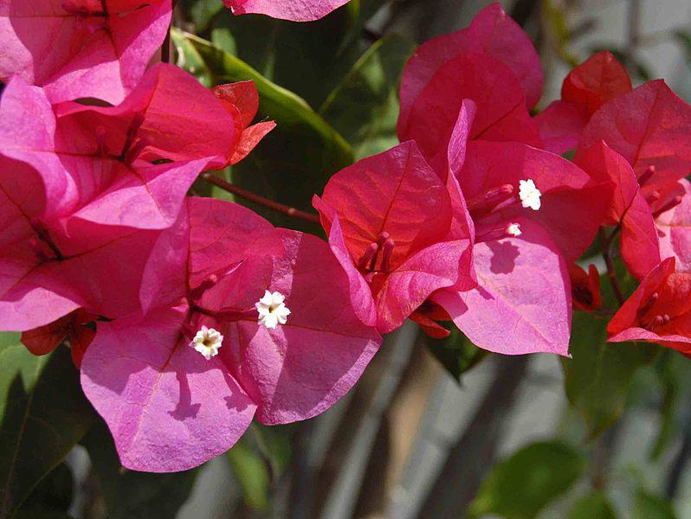

Caption for image source 1: Nyctaginaceae - Bougainvillea buttiana Flower surrended by bracts of Bougainvillea buttiana.

Image Source 2 -

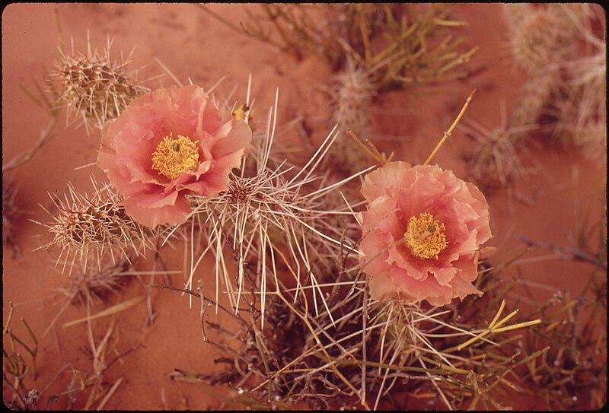

Caption for image source 2: ORANGE MALLOW, SHOWY DESERT FLOWER - NARA - 544877.

Example Question - "Is the Orange Globe Mallow and the Nyctaginaceae filamnet both pink?"

Example Answer - "No, the Orange Globe Mallow and the Nyctaginaceae filamnet are not both pink."

Generated Question - Are the flowers of Bougainvillea buttiana and the Orange Mallow surrounded by spines or bracts?

Generated Answer - The Bougainvillea buttiana flowers are surrounded by bracts, while the Orange Mallow flowers are surrounded by spines.

--- Entry for custom_id: d5da60840dba11ecb1e81171463288e9 ---

Example Question - What elements are used to create the explosive forces used by the technology that's currently being explored as a higher velocity alternative to conventional artillery?

Example Answer - Hydrogen and oxygen.

Image Source 1 -



Generated Question - How does the propellant used in modern 155 mm artillery ammunition differ from the gases used in combustion light-gas guns to achieve projectile acceleration?

Generated Answer - Modern 155 mm artillery uses solid nitrocellulose-based propellants, while combustion light-gas guns use hydrogen and oxygen gases.

--- Entry for custom_id: d5c385620dba11ecb1e81171463288e9 ---

Image Source 1 -

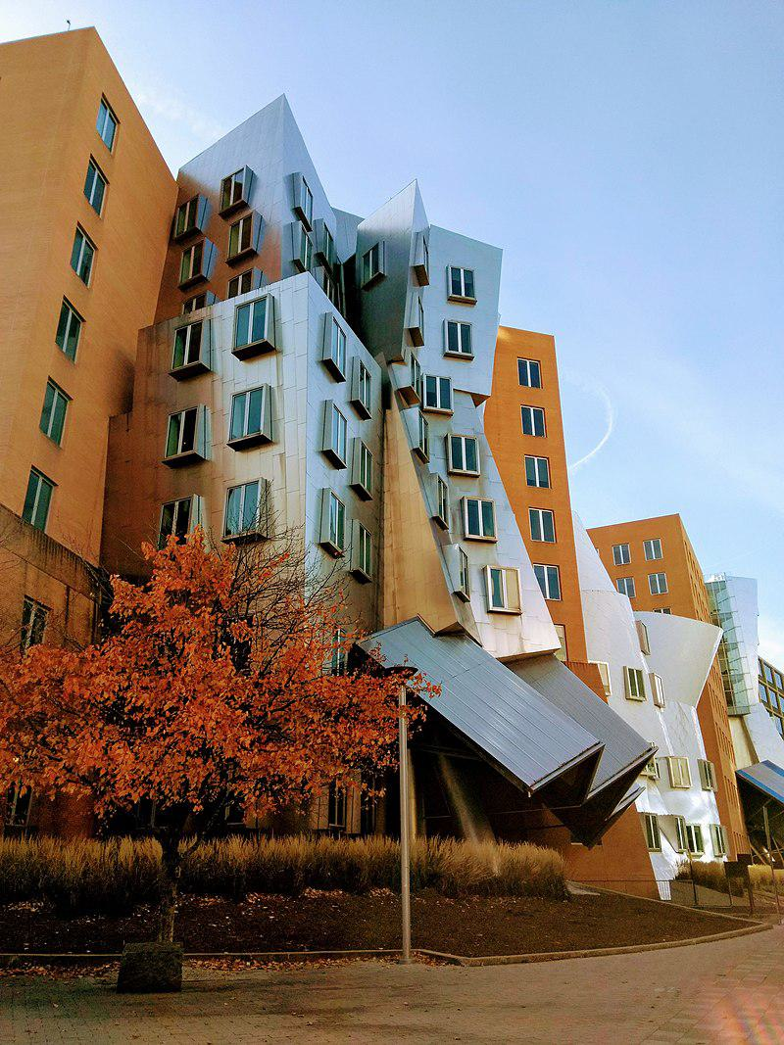

Caption for image source 1: Stata Center -MIT photo by Linda Fletcher.

Image Source 2 -

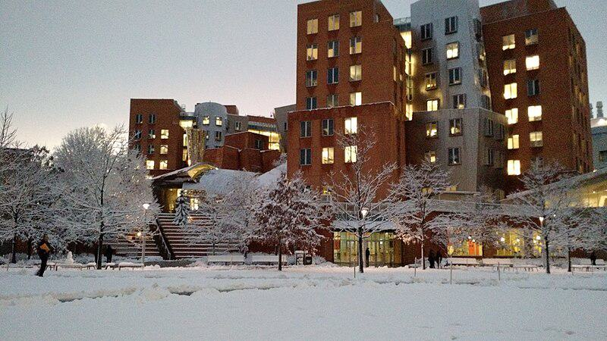

Caption for image source 2: Stata Center snow 2016 The Stata Center on the MIT Campus in snow, February 2016.

Example Question - "Are the buildings of the Stata Center uniform height?"

Example Answer - "The buildings of the Stata Center are not of uniform height."

Additional Text Source 1 - The wall and trees provide a uniform background for the chapel, and isolate the site from the noise and bustle of adjacent buildings. (from: MIT Chapel)

Generated Question - Does the Stata Center maintain a uniform appearance in both autumn and winter seasons despite the changing surroundings?

Generated Answer - No, the Stata Center's appearance contrasts with the autumn foliage and winter snow, showing different surroundings.

--- Entry for custom_id: d5dd1d740dba11ecb1e81171463288e9 ---

Example Question - Which person gave the island into which Somes Sound runs its name?

Example Answer - Samuel de Champlain gave Mount Desert Island, the island into which Somes Sound runs, its name.

Image Source 1 -

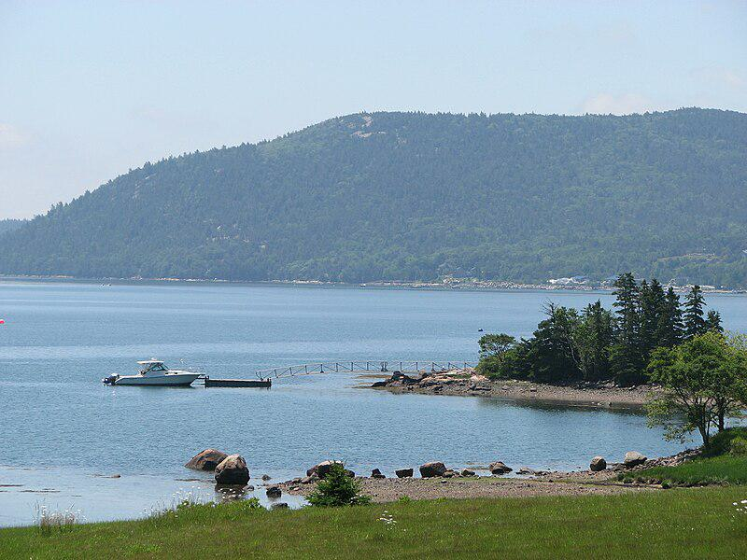

Generated Question - How deep is Somes Sound, the fjard visible from Mount Desert Island, and what is the island's significance?

Generated Answer - Somes Sound is about 175 feet deep, and Mount Desert Island is the largest island off Maine's coast.

--- Entry for custom_id: d5bfd3400dba11ecb1e81171463288e9 ---

Image Source 1 -

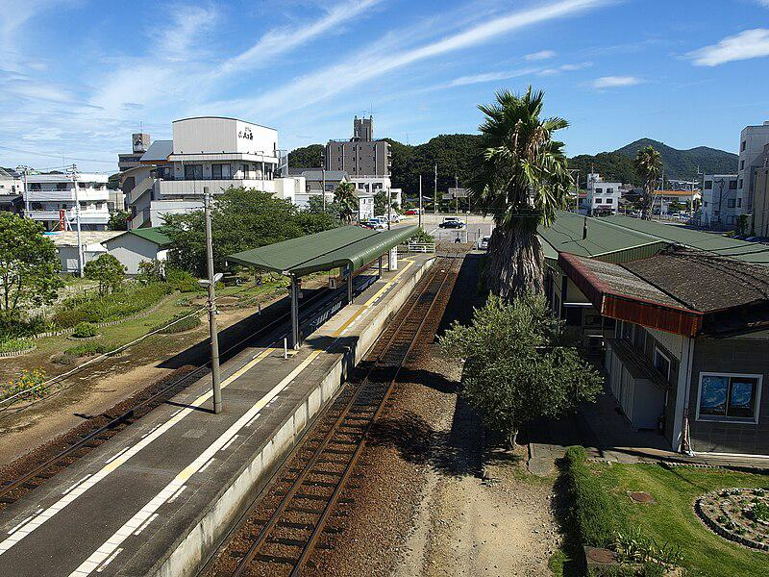

Caption for image source 1: Naruto railway station (overview) Naruto railway station overview ,Tokushima, Japan..

Example Question - "How many railway tracks appear at the Naruto railway station in Tokushima, Japan?"

Example Answer - "There are two railway tracks at the Naruto Railway Station in Tokushima, Japan."

Additional Text Source 1 - Konpiramae Station (金比羅前駅, Konpiramae-eki) is a railway station on the Naruto Line in Naruto, Tokushima Prefecture, Japan. It is operated by JR Shikoku and has the station number "N06". (from: Konpiramae Station)

Generated Question - Are Naruto railway station and Konpiramae Station both located in Naruto, Tokushima Prefecture, Japan?

Generated Answer - Yes, both stations are located in Naruto, Tokushima Prefecture, Japan.

--- Entry for custom_id: d5bfa64a0dba11ecb1e81171463288e9 ---

Image Source 1 -

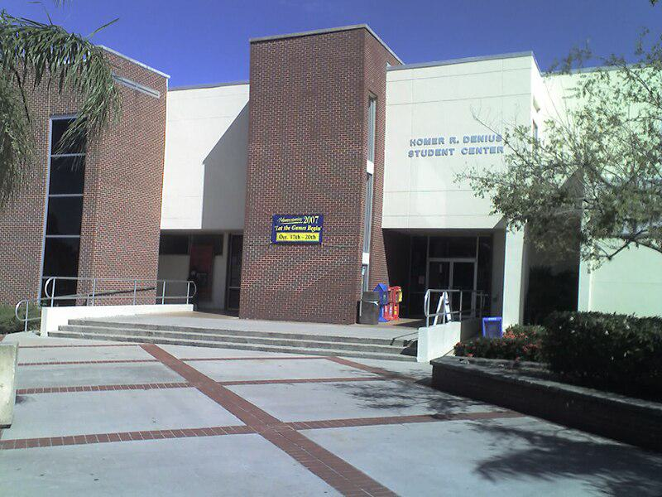

Caption for image source 1: FlTechSUB Florida Institute of Technology's Homer Denius Student Union Building, home to the campus bookstore, university mail annex, SUB Cafe, Office of Student Life, the John and Martha Hartley Room, as well as several student organizational offices..

Example Question - "Are there railings at the Florida Institute of Technology's Homer Denius Student Union Building?"

Example Answer - "Yes, there are railings."

Additional Text Source 1 - Florida Institute of Technology has 132 active student organizations on campus. The university-sponsored student organizations, such as Student Government Association, Campus Activities Board, the Homecoming Committee, FITV (CCTV Channel 99 on campus), and The Crimson (student-run university newspaper) operate in primary university funding. (from: Florida Institute of Technology)

Generated Question - Does the Florida Institute of Technology's Homer Denius Student Union Building likely support the activities of its 132 active student organizations?

Generated Answer - Yes, the building houses offices and spaces that support student organizations and activities.

--- Entry for custom_id: d5c3e5160dba11ecb1e81171463288e9 ---

Image Source 1 -



Caption for image source 1: The Rat (Graffiti in London) Banksy rat graffiti on City Road, London, United Kingdom..

Image Source 2 -



Caption for image source 2: Graffiti 47 on legal wall of PBS (2009) in Třebíč, Třebíč District Graffiti on legal wall of PBS factory in Trebic-Jejkov, Czech Republic..

Example Question - "What colors were used in the cartoon character in the Graffiti on legal wall of PBS factory that were not used in Banksy rat graffiti on City Road in London?"

Example Answer - "Red, blue, and yellow were used in the graffiti at the legal wall of PBS."

Additional Text Source 1 - Banksy no longer sells photographs or reproductions of his street graffiti, but his public "installations" are regularly resold, often even by removing the wall they were painted on. A small number of Banksy's works are officially, non-publicly, sold through an agency created by Banksy named Pest Control. (from: Banksy)

Generated Question - Can Banksy's rat graffiti on City Road be officially sold like the graffiti on the legal wall of PBS factory?

Generated Answer - No, Banksy's graffiti is rarely officially sold, unlike legal wall graffiti.

--- Entry for custom_id: d5c9d2460dba11ecb1e81171463288e9 ---

Image Source 1 -

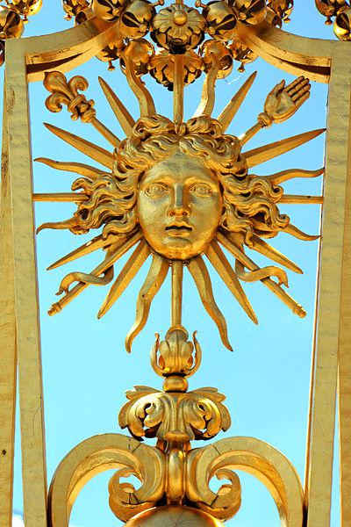

Caption for image source 1: Palace of Versailles - Louis XIV, 22 June 2014.

Example Question - "What human body part can be found on one of the spikes around the head on the Grille royale of Versailles, France?"

Example Answer - "A hand can be found on one of the spikes around the head on the Grille Royale of Versailles, France."

Additional Text Source 1 - The circulatory system consists of the heart and blood vessels (arteries, veins and capillaries). The heart propels the circulation of the blood, which serves as a "transportation system" to transfer oxygen, fuel, nutrients, waste products, immune cells and signalling molecules (i.e. hormones) from one part of the body to another. (from: Human body)

Generated Question - How does the heart in the circulatory system relate to the symbolic sun face in the Palace of Versailles grille?

Generated Answer - The heart circulates life like the sun face symbolizes life and energy.

--- Entry for custom_id: d5ca8bfa0dba11ecb1e81171463288e9 ---

Image Source 1 -



Caption for image source 1: Marissa Castelli Simon Shnapir 2013 U.S. Figure Skating Pairs Champions Marissa Castelli and Simon Shnapir stand atop the podium after becoming the 2013 U.S. Figure Skating Pairs Champions.

Example Question - "What color did Marissa Castelli wear after becoming the 2013 U.S. Figure Skating Pairs Champion?"

Example Answer - "Marissa Castelli wore the color red after becoming the 2013 U.S. Figure Skating Pairs Champion."

Additional Text Source 1 - None of the top three partnerships from 2012 competed in the pairs event, Denney / Coughlin being absent due to Coughlin's surgery and the other two pairs having split. Longtime pair Marissa Castelli / Simon Shnapir won the short program ahead of relatively new teams Felicia Zhang / Nathan Bartholomay and Alexa Scimeca / Christopher Knierim. (from: 2013 U.S. Figure Skating Championships)

Generated Question - Did Marissa Castelli and Simon Shnapir win the 2013 U.S. Figure Skating Pairs Championship despite the absence of the top three pairs from 2012?

Generated Answer - Yes, they won despite the absence of the top three pairs from 2012.

--- Entry for custom_id: d5d868b00dba11ecb1e81171463288e9 ---

Example Question - The public use Falcon Field and the state-owned facility located west of Adak in Alaska are both types of what?

Example Answer - Airports.

Image Source 1 -



Generated Question - Are both the Atlanta Regional Airport and Adak Airport used for public air travel and served by commercial airlines like Alaska Airlines?

Generated Answer - Yes, both airports are public use and served by commercial airlines.

--- Entry for custom_id: d5ddccba0dba11ecb1e81171463288e9 ---

Example Question - What type of armor and weapons would Spartacus have likely worn as a gladiator?

Example Answer - He would have probably worn a small rectangular, square or circular shield and a very short sword with a slightly curved blade.

Image Source 1 -

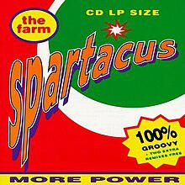

Generated Question - How does the image of the "Spartacus" album cover relate to the historical figure Spartacus and his gladiator weapons?

Generated Answer - The album cover name references Spartacus, who likely used a small shield and short curved sword as a Thracian gladiator.

--- Entry for custom_id: d5bf5dd40dba11ecb1e81171463288e9 ---

Image Source 1 -

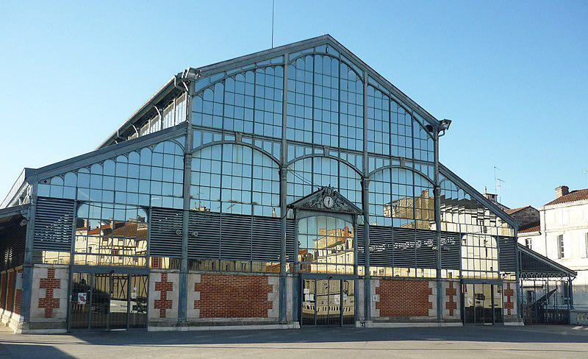

Caption for image source 1: Halles de Niort.

Example Question - "How many people are around the clock in the sculpture over the door of the Halles de Niort?"

Example Answer - "There are 4 people around the clock."

Additional Text Source 1 - There are no airports with scheduled airline service within the département, although Niort-Souche Airport is used for private movements. The nearest commercial airports are at Poitiers (Poitiers - Biard Airport), La Rochelle (La Rochelle - Île de Ré Airport) and Nantes (Nantes Atlantique Airport). (from: Deux-Sèvres)

Generated Question - Is the Halles de Niort located near any commercial airports mentioned in the Deux-Sèvres département text?

Generated Answer - Yes, it is near commercial airports at Poitiers, La Rochelle, and Nantes.

--- Entry for custom_id: d5db3c160dba11ecb1e81171463288e9 ---

Example Question - In Arthurian legend, the father of Lancelot and Hector de Maris takes which king's sister-in-law to be his wife?

Example Answer - Ban marries the sister to King Bors's wife.

Image Source 1 -

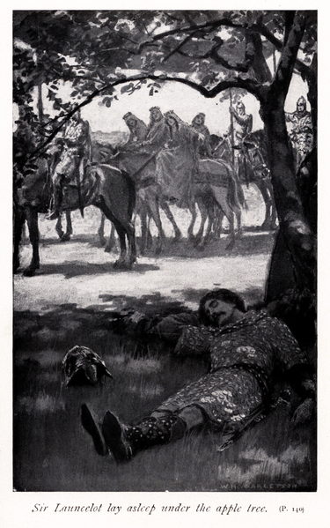

Generated Question - How is the sleeping figure under the apple tree in the illustration related to King Ban and his wife Elaine?

Generated Answer - The sleeping figure is Lancelot, son of King Ban and Elaine.

--- Entry for custom_id: d5da5b7a0dba11ecb1e81171463288e9 ---

Example Question - How big is the diameter of the smooth cap in the mycorrhizal organism that lives in symbiosis with the trees?

Example Answer - About 4–10 cm.

Image Source 1 -



--- Entry for custom_id: d5d416340dba11ecb1e81171463288e9 ---

Example Question - Did Ron McLarty or Peter Thomas live to a longer age?

Example Answer - Peter Thomas lived to a longer age.

Image Source 1 -

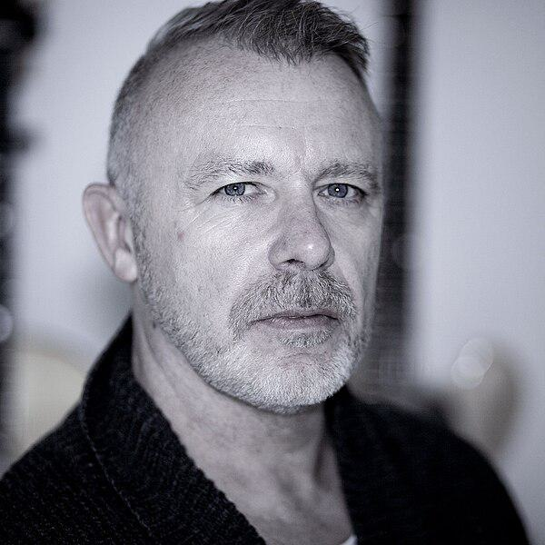

Generated Question - Based on their careers and the image, is Peter James Thomas likely the same person as Peter Addenbrooke Thomas, the announcer?

Generated Answer - Yes, Peter James Thomas is likely the same person as Peter Addenbrooke Thomas, the announcer.

--- Entry for custom_id: d5c9e6f00dba11ecb1e81171463288e9 ---

Image Source 1 -

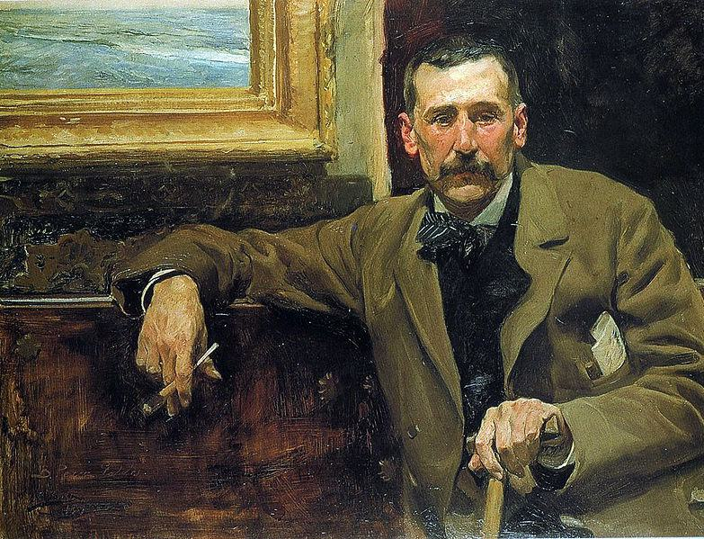

Caption for image source 1: Perez galdos.

Image Source 2 -

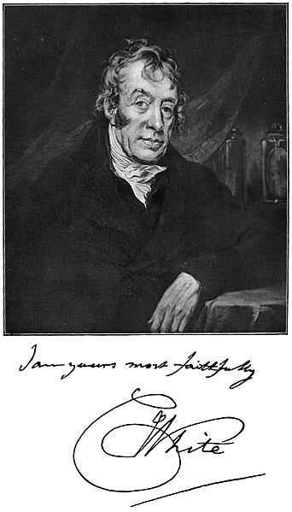

Caption for image source 2: White Charles physician Picture of Charles White, the physician.

Example Question - "Are the men in Joaquín Sorolla's "Portrait of Benito Pérez Galdós" and photograph of "Picture of Charles White, the physician" (taken in 1904) sitting down?"

Example Answer - "The men in Joaquín Sorolla's "Portrait of Benito Pérez Galdós" and photograph of "Picture of Charles White, the physician" (taken in 1904) are sitting down."

Additional Text Source 1 - Portrait of Benito Pérez Galdós (Spanish: Retrato de Benito Pérez Galdós is an oil portrait painting by Joaquín Sorolla in 1894. It represents the Spanish writer Benito Pérez Galdós at aged 51.In 1973 it was acquired by the grandsons of Galdós for the Cabildo Insular de Gran Canaria. (from: Portrait of Benito Pérez Galdós)

--- Entry for custom_id: d5d589ba0dba11ecb1e81171463288e9 ---

Example Question - Who were the parents of the god in Norse mythology projected as the husband of the goddes Frigg?

Example Answer - Odin is the son of Bestla and Borr

Image Source 1 -

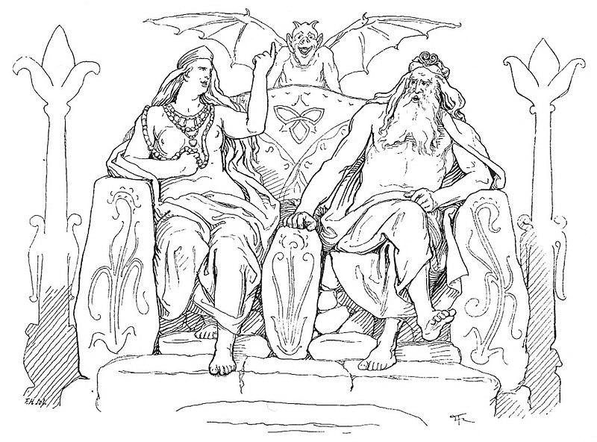

Generated Question - Which god, son of Bestla and Borr, is depicted sitting with the goddess Frigg and associated with wisdom and war?

Generated Answer - Odin is the son of Bestla and Borr, depicted with Frigg and associated with wisdom and war.

--- Entry for custom_id: d5dd0c9e0dba11ecb1e81171463288e9 ---

Example Question - What color are the bill and feet of the bar-tailed trogon and the belly of the male black-throated trogon?

Example Answer - yellow

Image Source 1 -

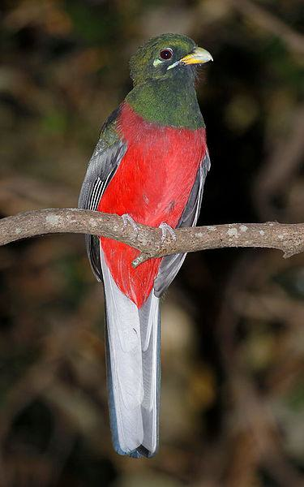

Generated Question - Which trogon species mentioned has a blue-black head with bronze iridescence, and which has a green head and golden yellow belly?

Generated Answer - The bar-tailed trogon has a blue-black head with bronze iridescence, and the black-throated trogon has a green head and golden yellow belly.

--- Entry for custom_id: d5ccb01a0dba11ecb1e81171463288e9 ---

Image Source 1 -

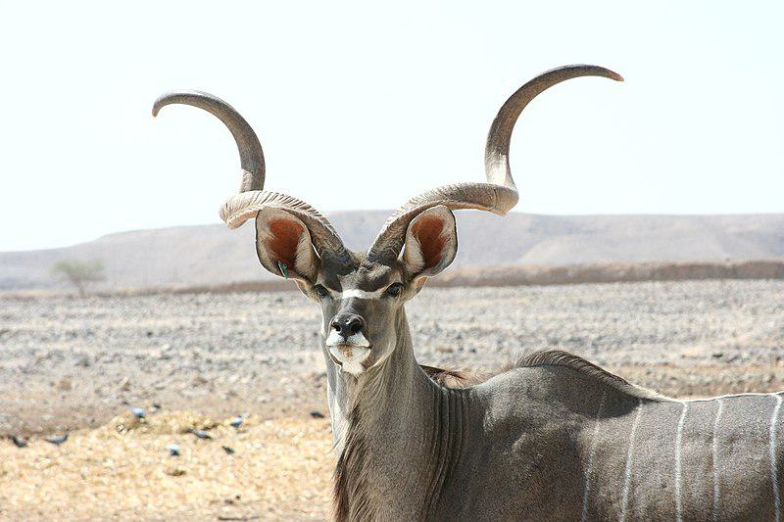

Caption for image source 1: Kudu antelope Kudu at antelpe ranch, Israel.

Example Question - "What shape are the horns of a Kudu Antelope?"

Example Answer - "The horns of the Kudu Antelope are spiral shaped."

Additional Text Source 1 - The alternative name "Strepsicerotini" was published by another British zoologist John Edward Gray as "Strepsiceriae" earlier in 1846. It comes from Greek with στρεπτός (streptós) meaning "twisted" and κέρατος (kératos) meaning "horn", referring to the shape of this group's horns. (from: Tragelaphini)

Generated Question - Does the name "Strepsicerotini" relate to the twisted shape of the Kudu antelope's horns?

Generated Answer - Yes, "Strepsicerotini" means twisted horn, describing the Kudu's spiral horns.

--- Entry for custom_id: d5bca3140dba11ecb1e81171463288e9 ---

Image Source 1 -

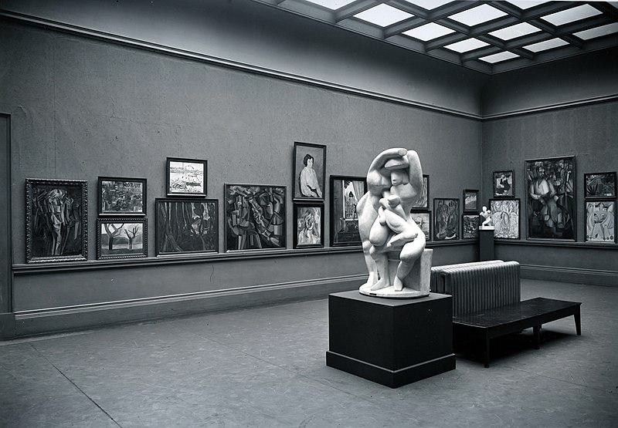

Caption for image source 1: Armory Show, International Exhibition of Modern Art, Chicago, 1913. The Cubist room.

Example Question - "How many sculptures are on display in the Cubist Room at the Armory Show International Exhibition of Modern Art?"

Example Answer - "There are two sculptures on display in the Cubist Room at the Armory Show International Exhibition of Modern Art."

Additional Text Source 1 - The DePaul Art Museum in Chicago, Illinois presented For and Against Modern Art: The Armory Show +100, from April 4 to June 16, 2013. The International Print Center in New York held an exhibition, "1913 Armory Show Revisited: the Artists and their Prints," of prints from the show or by artists whose work in other media was included. (from: Armory Show)

Generated Question - Did the Armory Show's Cubist Room in 1913 include both paintings and sculptures in its display?

Generated Answer - Yes, the Cubist Room displayed both paintings and sculptures.

--- Entry for custom_id: d5c704120dba11ecb1e81171463288e9 ---

Image Source 1 -



Caption for image source 1: Mycena parsonsiae 44171.

Image Source 2 -



Caption for image source 2: Mycena leaiana 58075.

Example Question - "What kind of surface can Mycena leaiana and Mycena parsonsiae grow on?"

Example Answer - "They can grow on a rock surface."

Additional Text Source 1 - Mycena galopus, commonly known as the milking bonnet or the milk-drop mycena, is an inedible species of fungus in the family Mycenaceae of the order Agaricales. It produces small mushrooms that have grayish-brown, bell-shaped, radially-grooved caps up to 2.5 cm (1 in) wide. (from: Mycena galopus)

Generated Question - Are Mycena parsonsiae and Mycena leaiana similar in cap shape despite their different colors and sizes?

Generated Answer - Yes, both have bell-shaped caps with radial grooves.

--- Entry for custom_id: d5d43e3e0dba11ecb1e81171463288e9 ---

Example Question - Did Adrien Brody win his Academy Award for Best Actor for The Pianist in the same year that Bill Murray won a Golden Globe award for Lost in Translation?

Example Answer - no

Image Source 1 -

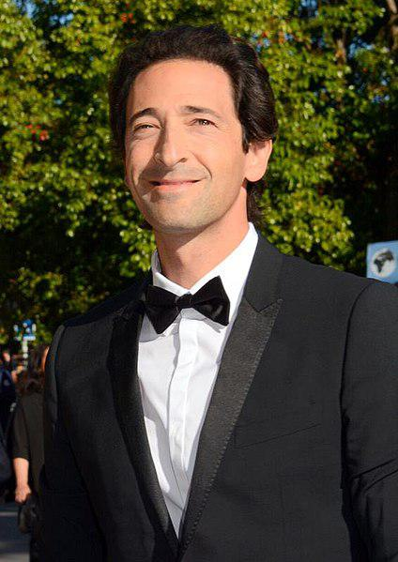

Generated Question - Did Adrien Brody become the youngest actor to win an Academy Award for Best Actor before Bill Murray received his Oscar nomination for Lost in Translation?

Generated Answer - Yes, Adrien Brody won the Academy Award before Bill Murray's nomination.

--- Entry for custom_id: d5cfe1680dba11ecb1e81171463288e9 ---

Example Question - How many vase painters have been identified by people who sometimes studied disjecta membra?

Example Answer - Over 2800 painters have been identified.

Image Source 1 -

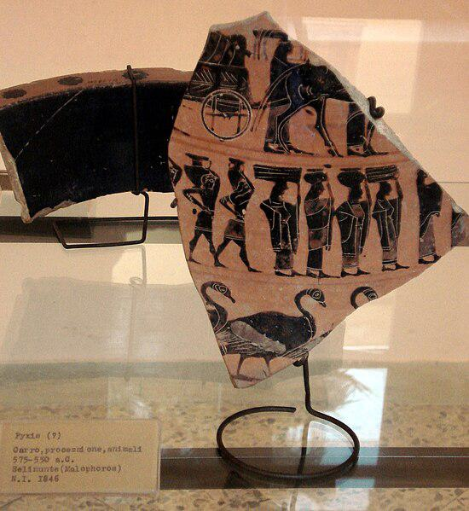

Generated Question - How do scholars identify individual ancient Greek vase painters using fragments like the one shown in the image?

Generated Answer - Scholars attribute painted fragments, called disjecta membra, to individual artists by studying their style.

--- Entry for custom_id: d5ccabc40dba11ecb1e81171463288e9 ---

Image Source 1 -

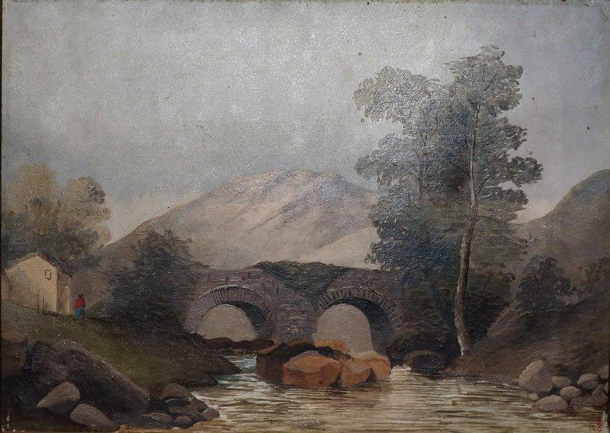

Caption for image source 1: Scottish Landscape, oil on canvas painting by Princess Victoria Kaiulani, c. 1891, Bishop Museum Scottish Landscape, oil on canvas painting by Princess Victoria Kaiulani, c. 1891, Bishop Museum.

Image Source 2 -

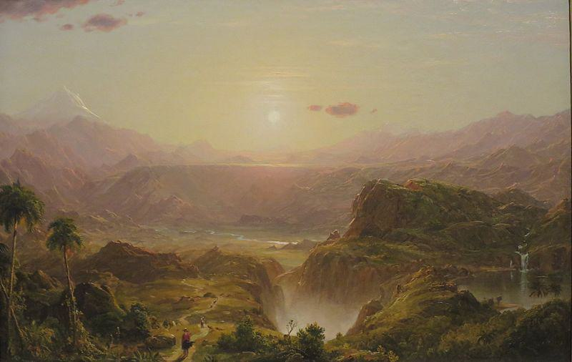

Caption for image source 2: 'The Andes of Ecuador', oil on canvas painting by Frederic Adwin Church, 1855, HAA The Andes of Ecuador oil on canvas painting by Frederic Edwin Church, 1855, Honolulu Museum of Art accession 56221.

Example Question - "In which painting is the sun visible: The Andes of Ecuador by Frederic Adwin Church or Scottish Landscape by by Princess Victoria Kaiulani?"

Example Answer - "The sun visible in the painting The Andes of Ecuador by Frederic Adwin Church."

Additional Text Source 1 - He later wrote to his friend Will Hicok Low, "If you want to cease to be Republican, see my little Kaiulani, as she goes through [the United States]." Historian A. Grove Day noted, "Of all his island friendships, the platonic affair with the half-Scottish princess has most persisted in the imagination of lovers of Hawaiiana." (from: Kaʻiulani)

Generated Question - Considering the landscapes and the historical connection, which painting likely reflects the heritage of Princess Victoria Kaiulani?

Generated Answer - The Scottish Landscape likely reflects Princess Victoria Kaiulani's heritage due to her half-Scottish background.

--- Entry for custom_id: d5c6d0aa0dba11ecb1e81171463288e9 ---

Image Source 1 -

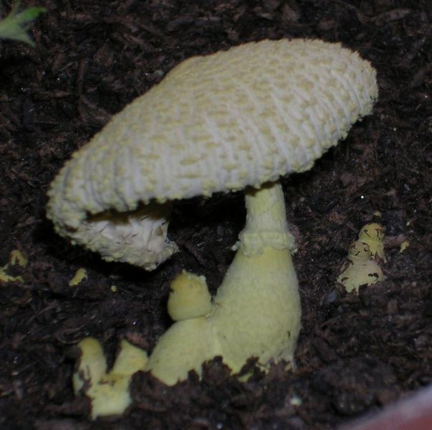

Caption for image source 1: Leucocoprinus birnbaumii.

Image Source 2 -



Caption for image source 2: Laccaria amethysteo-occidentalis (32942930552).

Example Question - "Which fungus top looks most like it was knit; Leucocoprinus birnbaumii or Laccaria amethysteo-occidentalis?"

Example Answer - "The Leucocoprinus birnbaumii fungus top looks most like it was knit."

Additional Text Source 1 - In the UK, Leucocoprinus birnbaumii has been given the recommended common name of "plantpot dapperling". In North America, it has also been called the "yellow parasol", "flowerpot parasol", "yellow houseplant mushroom", "lemon-yellow lepiota", or "yellow pleated parasol". (from: Leucocoprinus birnbaumii)

Generated Question - Considering their common names, which fungus is more associated with indoor plants, Leucocoprinus birnbaumii or Laccaria amethysteo-occidentalis?

Generated Answer - Leucocoprinus birnbaumii is more associated with indoor plants.

--- Entry for custom_id: d5c9a97e0dba11ecb1e81171463288e9 ---

Image Source 1 -

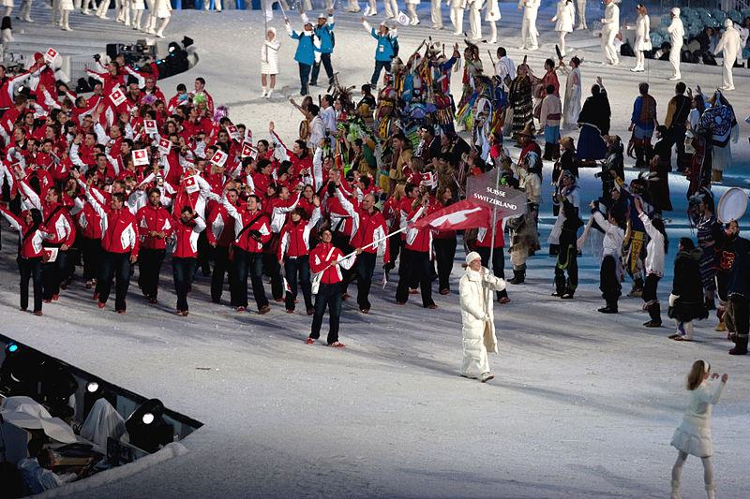

Caption for image source 1: 2010 Opening Ceremony - Switzerland entering.

Image Source 2 -

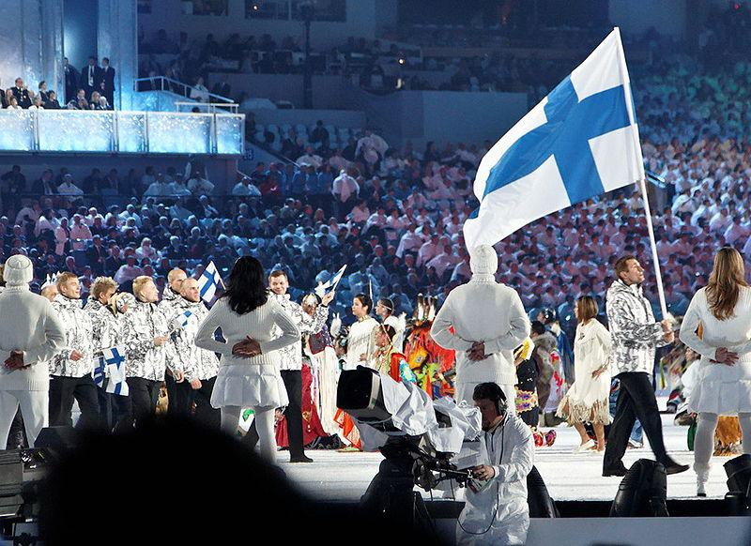

Caption for image source 2: 2010 Olympic Winter Games Opening Ceremony - Finland entering cropped.

Example Question - "Which nation in the 2010 Winter Olympics opening ceremony had more white in their uniforms: Finland or Switzerland?"

Example Answer - "Finland had more white in their uniforms than Switzerland."

Additional Text Source 1 - A soundtrack, Sounds of Vancouver 2010: Opening Ceremony Commemorative Album (French: Musique de Vancouver 2010 : L'album commémoratif de la cérémonie d'ouverture des Jeux), was released through the iTunes Store on February 12, 2010, containing many studio recordings of the performances from the opening ceremony. (from: 2010 Winter Olympics opening ceremony)

Generated Question - Did the 2010 Winter Olympics opening ceremony feature both Switzerland and Finland teams entering with their national flags?

Generated Answer - Yes, both Switzerland and Finland teams entered carrying their national flags.

--- Entry for custom_id: d5cfb54e0dba11ecb1e81171463288e9 ---

Example Question - What was the name of the home arena to the Texas Stars of the American Hockey League when WrestleMania 29 took place?

Example Answer - Cedar Park Center

Image Source 1 -



Generated Question - Did Aristobulus negotiate with Pompey at a mountain fortress while WrestleMania 29 took place in the arena originally named Cedar Park Center?

Generated Answer - Yes, Aristobulus negotiated at a mountain fortress, and WrestleMania 29 took place at Cedar Park Center.

--- Entry for custom_id: d5c449c00dba11ecb1e81171463288e9 ---

Image Source 1 -

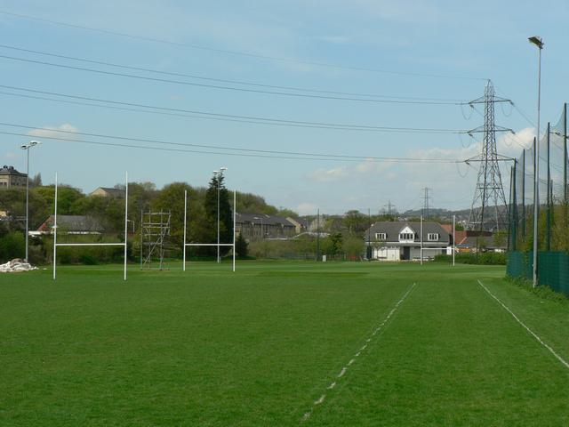

Caption for image source 1: Leeds Rugby Academy, Kirkstall - geograph.org.uk - 165339 Leeds Rugby Academy, Kirkstall. Looking along the fence on the east side adjacent to Morrisons..

Image Source 2 -

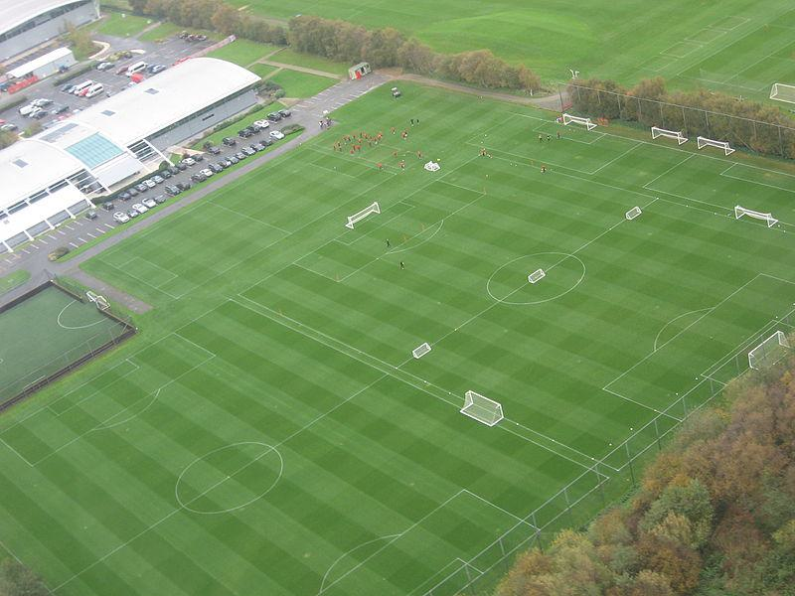

Caption for image source 2: MUFC training ground Carrington.

Example Question - "Are there light posts next to the field at both Leeds rugby Academy in kirkstall and the MUFC training ground in Carrington?"

Example Answer - "No, there are no light posts next to the field at Leeds rugby Academy in Kirkstall or the MUFC training ground in Carrington."

Additional Text Source 1 - The Under-16s and Under-18s typically play their academy league games at 11am on Saturday mornings at Carrington, while Youth Cup games are generally played at either Altrincham's Moss Lane ground (where the under-23s play their home games) or the club's 76,000-capacity Old Trafford home, in order to cater for the greater number of supporters these fixtures attract. (from: Manchester United F.C. Reserves and Academy)

Generated Question - Do both Leeds Rugby Academy and MUFC training ground Carrington host youth games on weekends?

Generated Answer - Only MUFC training ground Carrington hosts youth games on Saturday mornings.

--- Entry for custom_id: d5c3d3960dba11ecb1e81171463288e9 ---

Image Source 1 -



Caption for image source 1: Grasset-decembre.

Image Source 2 -

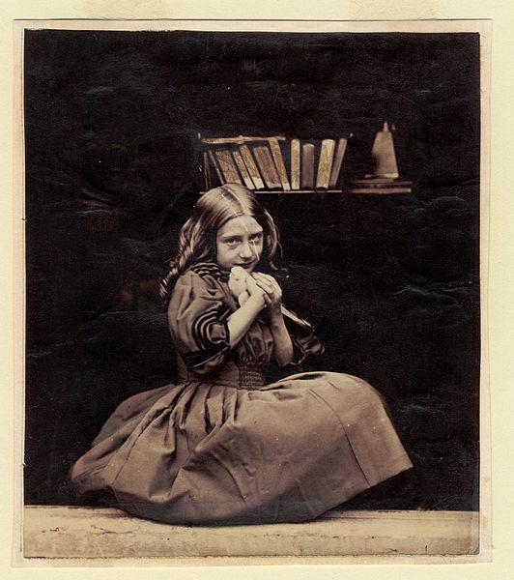

Caption for image source 2: Rejlander045 No title.

Example Question - "Which painting is more colorful, the "Decembre" by Eugène Grasset or the "Girl with dove" by Oscar Gustave Rejlander?"

Example Answer - "Decembre is more colorful than Girl with dove."

Additional Text Source 1 - Hugues Lebailly has endeavoured to set Dodgson's child photography within the "Victorian Child Cult", which perceived child nudity as essentially an expression of innocence. Lebailly claims that studies of child nudes were mainstream and fashionable in Dodgson's time and that most photographers made them as a matter of course, including Oscar Gustave Rejlander and Julia Margaret Cameron. (from: Lewis Carroll)

Generated Question - Considering the Victorian Child Cult context, which image likely reflects the era's innocence ideal more, the colorful "Decembre" or the black-and-white "Girl with dove"?

Generated Answer - The black-and-white "Girl with dove" likely reflects the Victorian innocence ideal more.

--- Entry for custom_id: d5d1f1060dba11ecb1e81171463288e9 ---

Example Question - What is the weight range for squids that are part of the Cephalopod molluscs phylum?

Example Answer - They can range in weight between 0.1 kg to 495 kg.

Image Source 1 -

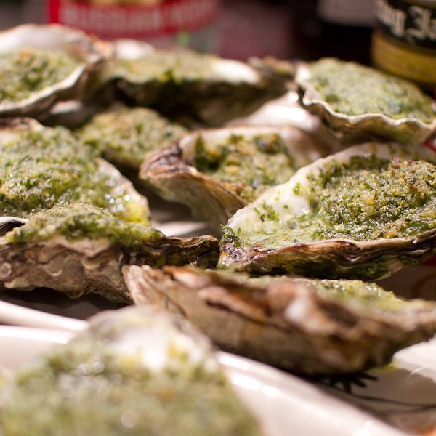

Generated Question - How do the weights of colossal squids compare to the edible molluscs used in dishes like Oysters Rockefeller?

Generated Answer - Colossal squids weigh up to 495 kg, much heavier than typical edible molluscs like oysters.

--- Entry for custom_id: d5c40a8c0dba11ecb1e81171463288e9 ---

Image Source 1 -

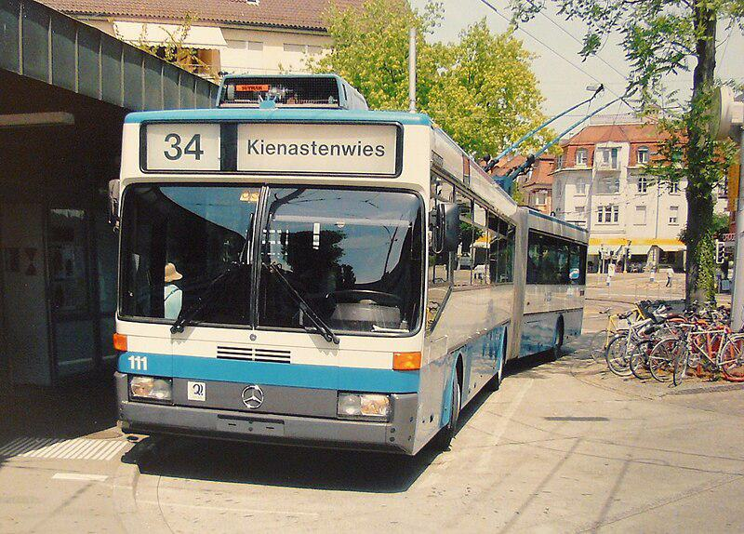

Caption for image source 1: Klausplatz Zurich trolleybus Mercedes-Benz trolleybus (#111) at Klusplatz in Zurich, Switzerland..

Example Question - "What brand of buses are used at Klusplatz in Zurich, Switzerland?"

Example Answer - "The buses at Klusplatz in Zurich, Switzerland are Mercedes Benz."

Additional Text Source 1 - In 1970 the PFLP obtained the release of the three terrorists convicted in Switzerland and other comrades-in-arms imprisoned abroad through coordinated hijackings. Flights affected were SR 100 (Zurich-New York), TWA flight TW741, Pan Am flight PA93 and BOAC flight BA775. (from: Zurich Airport)

Generated Question - Is the Mercedes-Benz trolleybus at Klausplatz in Zurich related to the 1970 hijackings involving flights from Zurich Airport?

Generated Answer - No, the trolleybus and the 1970 hijackings at Zurich Airport are unrelated.

--- Entry for custom_id: d5d0f5c60dba11ecb1e81171463288e9 ---

Example Question - On what highway in California were there cars overturned during the outbreak of weak tornadoes in Santa Barbara and Orange Counties between January 19 and January 21, 2010?

Example Answer - The cars were overturned on the Pacific Coast Highway.

Image Source 1 -

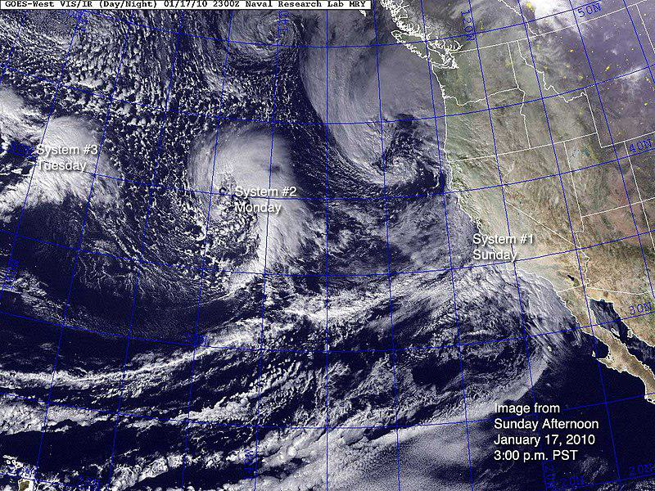

Generated Question - How many storm systems were visible off the California coast on January 17, 2010, before the tornado outbreak in Santa Barbara and Orange Counties?

Generated Answer - Three storm systems were visible off the California coast on January 17, 2010.

--- Entry for custom_id: d5d0210a0dba11ecb1e81171463288e9 ---

Example Question - What title can the older youth of the Sea Scouts elect a youth leader to that is also a member of a U.S. Navy gun crew?

Example Answer - They can be given the title 'boatswain".

Image Source 1 -

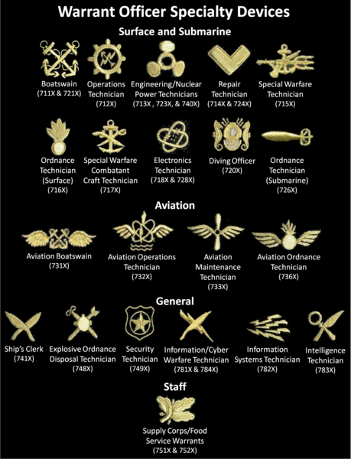

--- Entry for custom_id: d5dde1d20dba11ecb1e81171463288e9 ---

Example Question - Egbert Benson and John Jay had descent from what people whose colonization of the Americas began with the establishment of trading posts and plantations?

Example Answer - Dutch

Image Source 1 -

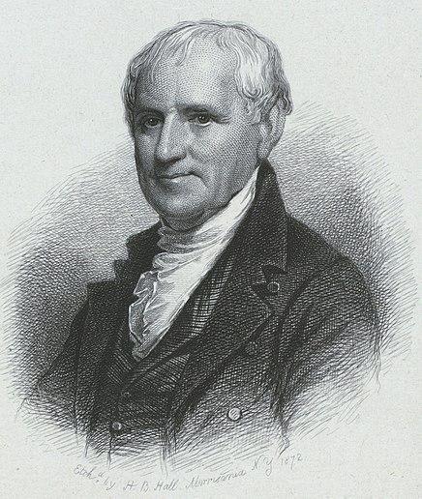

Generated Question - Which colonizing people, known for early trading posts in the Americas, were ancestors of Egbert Benson shown in the image?

Generated Answer - Dutch

--- Entry for custom_id: d5cc0cc80dba11ecb1e81171463288e9 ---

Image Source 1 -

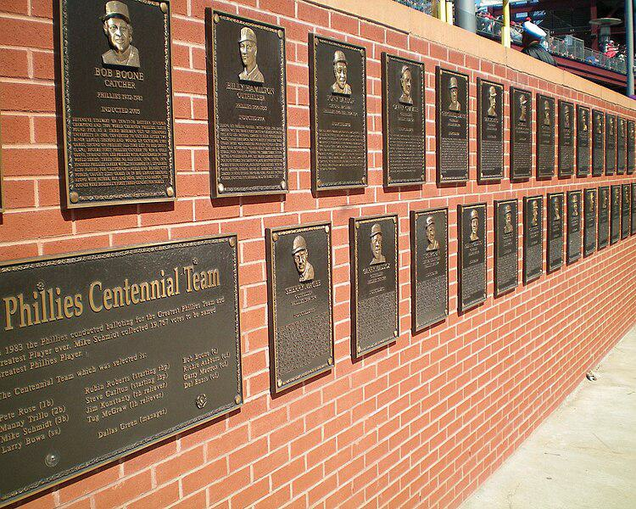

Caption for image source 1: PhilliesWallofFame This is the Phillies Wall of Fame at Citizens Bank Park, Philadelphia, PA..

Example Question - "What kind of wall holds the Phillies Wall of Fame at Citizens Bank Park, Philadelphia, PA?"

Example Answer - "A brick wall holds the Phillies Wall of Fame at Citizens Bank Park, Philadelphia, PA."

Additional Text Source 1 - In addition to Tropicana Field in St. Petersburg, Citizens Bank Park (Philadelphia Phillies), Truist Park (Atlanta Braves), Yankee Stadium (New York Yankees), and Globe Life Field (Texas Rangers) are the only current venues that have not yet hosted an All-Star Game. (from: List of Major League Baseball All-Star Games)

Generated Question - Is the Phillies Wall of Fame located in a stadium that has hosted an All-Star Game?

Generated Answer - No, Citizens Bank Park has not yet hosted an All-Star Game.

--- Entry for custom_id: d5c0f2f20dba11ecb1e81171463288e9 ---

Image Source 1 -

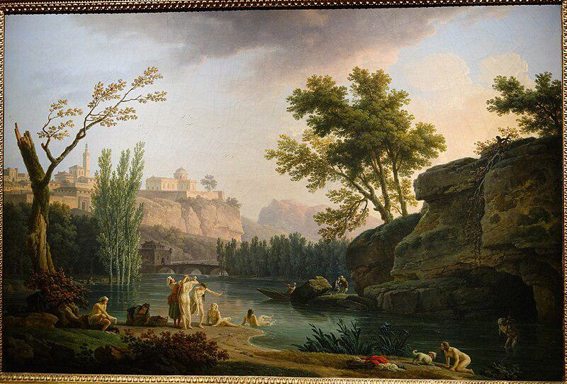

Caption for image source 1: Summer Evening, Landscape in Italy, view 2, by Joseph Vernet, 1773, oil on canvas - National Museum of Western Art, Tokyo - DSC08554 Painting in the National Museum of Western Art, Tokyo, Japan. This artwork is in the public domain because the artist died more than 70 years ago. Photography was permitted in the museum without restriction..

Image Source 2 -

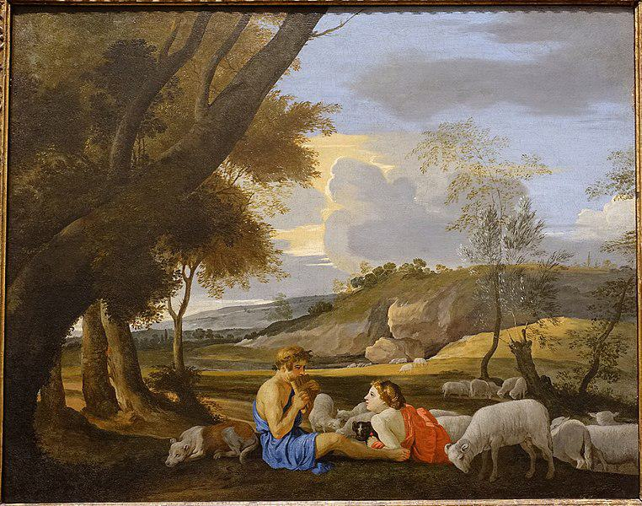

Caption for image source 2: Arcadian Landscape, by the circle of Nicolas Poussin, c. 1627-1628, oil on canvas - Blanton Museum of Art - Austin, Texas - DSC07880 Arcadian Landscape.

Example Question - "Is there a dog in Joseph Vernet's "Summer Evening, Landscape in Italy" and "Arcadian Landscape, by the circle of Nicolas Poussin"?"

Example Answer - "There is a dog in both Joseph Vernet's "Summer Evening, Landscape in Italy" and "Arcadian Landscape, by the circle of Nicolas Poussin"."

Additional Text Source 1 - Et in Arcadia ego (also known as Les bergers d'Arcadie or The Arcadian Shepherds) is a 1637–38 painting by Nicolas Poussin (1594–1665), the leading painter of the classical French Baroque style. It depicts a pastoral scene with idealized shepherds from classical antiquity, and a woman, possibly a shepherdess, gathered around an austere tomb. (from: Et in Arcadia ego)

Generated Question - Do both paintings depict natural landscapes with human figures interacting with animals?

Generated Answer - Yes, both paintings show natural landscapes with humans and animals interacting.

--- Entry for custom_id: d5d60a980dba11ecb1e81171463288e9 ---

Example Question - According to legend, Dangun founded the first kingdom in what place where monarchy existed until the end of the Japanese occupation?

Example Answer - Korea

Image Source 1 -



Generated Question - Where is the legendary birthplace of Korea's first kingdom located, as shown by the lake where Dangun's father descended from heaven?

Generated Answer - Baekdu Mountain at Heaven Lake.

--- Entry for custom_id: d5d9ed700dba11ecb1e81171463288e9 ---

Example Question - The high peak called Golden Hinde can be found in what area that the twin summits the Lions Gate Bridge was named in their honor are in?

Example Answer - Vancouver.

Image Source 1 -

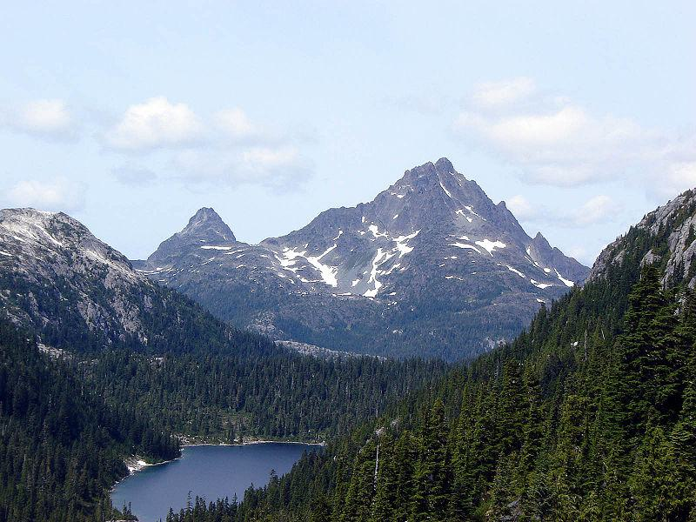

Generated Question - Are the Golden Hinde and the Lions peaks located on the same island or mainland area near Vancouver?

Generated Answer - No, Golden Hinde is on Vancouver Island, while the Lions peaks are near mainland Vancouver.

--- Entry for custom_id: d5c555a40dba11ecb1e81171463288e9 ---

Image Source 1 -

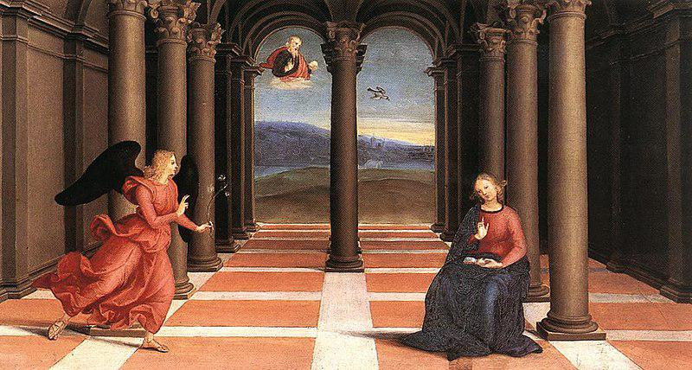

Caption for image source 1: Raphael - The Annunciation (Oddi altar).

Example Question - "What is the angel in The Annunciation Oddi altar holding in her hand?"

Example Answer - "The angel in The Annunciation Oddi Alter is holding an olive branch."

--- Entry for custom_id: d5d1e0e40dba11ecb1e81171463288e9 ---

Example Question - Does relation of ideas impact relational theory?

Example Answer - It does not.

Image Source 1 -



--- Entry for custom_id: d5c31f1e0dba11ecb1e81171463288e9 ---

Image Source 1 -

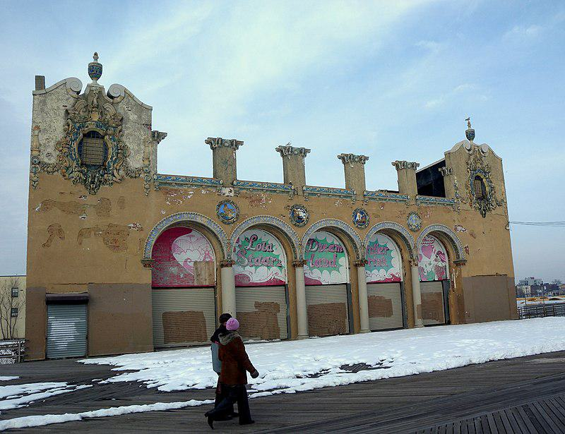

Caption for image source 1: Childs Restaurant CI jeh Looking north at former Childs Restaurant on a cloudy New Years Day after the Polar Bear plunge..

Image Source 2 -

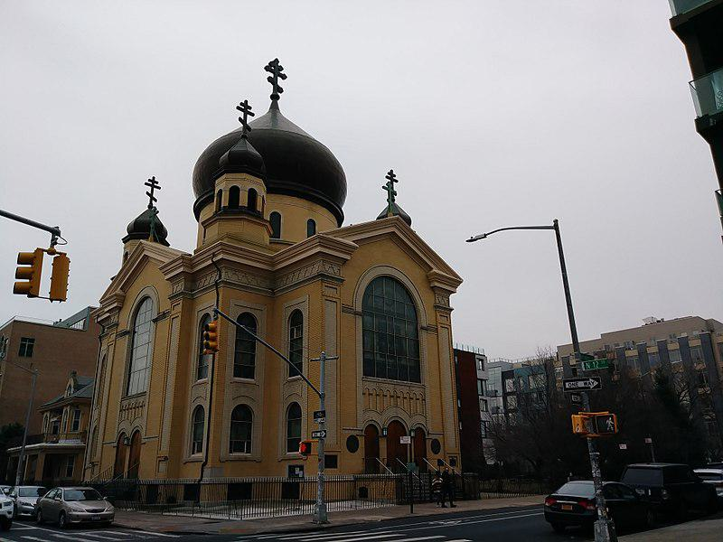

Caption for image source 2: Cathedral of the Transfiguration of Our Lord (28407618089).

Example Question - "What color is both the Cathedral of the Transfiguration of Our Lord Building and the Child's Restaurant Building?"

Example Answer - "The Cathedral of the Transfiguration of Our Lord building and the Child's Restaurant building are both brown."

Additional Text Source 1 - The Cathedral of the Transfiguration of Our Lord (Russian: Собор Преображения Господня) also called Catholic Cathedral of Atyrau is a religious building affiliated with the Catholic Church which is in the Avangard street of the city of Atyrau, 2 in Eurasian country of Kazakhstan, and which serves as the seat of the apostolic administration of Atyrau. (from: Cathedral of the Transfiguration of Our Lord, Atyrau)

Generated Question - Are the Cathedral of the Transfiguration of Our Lord in Kazakhstan and the Childs Restaurant building both used for religious purposes?

Generated Answer - No, only the Cathedral of the Transfiguration of Our Lord is used for religious purposes.

--- Entry for custom_id: d5dacd620dba11ecb1e81171463288e9 ---

Example Question - What type of rimless bottlenecked rifle cartridge was developed in the 1950's that the general purpose machine gun designated the General Support Machine Gun (GSMG) is chambered for?

Example Answer - 7.62x51mm NATO

Image Source 1 -

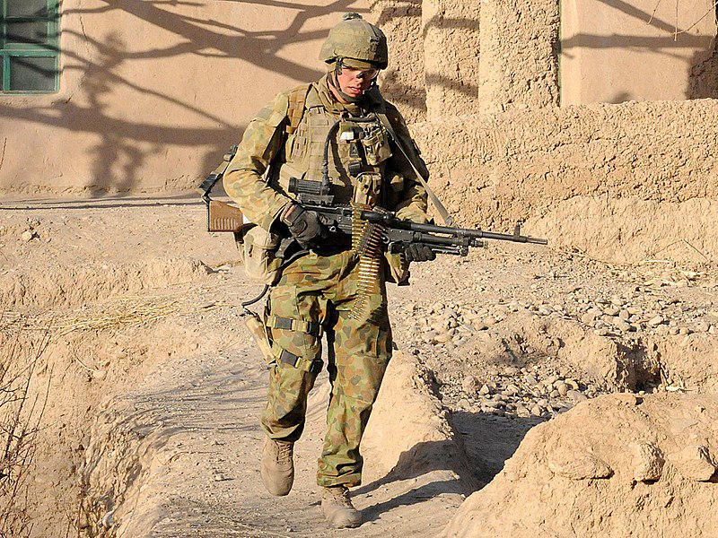

Generated Question - What general-purpose machine gun chambered for 7.62×51mm NATO replaced the M60 and is shown in the image with the soldier?

Generated Answer - The FN MAG 58, designated the General Support Machine Gun (GSMG).

--- Entry for custom_id: d5cd7d420dba11ecb1e81171463288e9 ---

Image Source 1 -

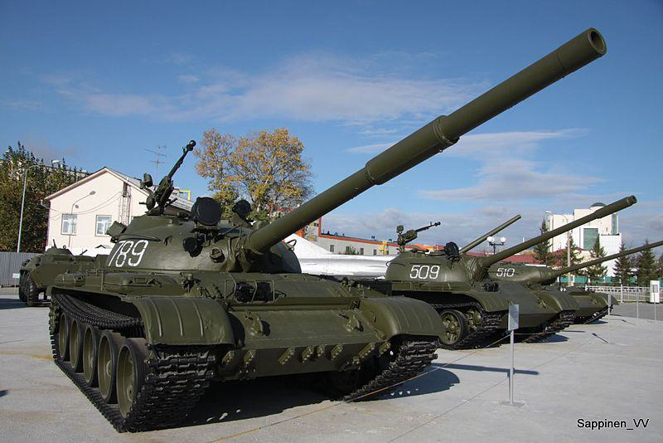

Caption for image source 1: Verkhnyaya Pyshma Tank Museum 2012 0071 Verkhnyaya Pyshma Tank Museum 2012.

Example Question - "What are some numbers of the tanks at the Verkhnyaya Pyshma Tank Museum?"

Example Answer - "The numbers of the tanks at the Verkhnyaya Pyshma Tank Museum are 789, 509 and 510."

Additional Text Source 1 - The UMMC Museum Complex (Russian: Музейный комплекс УГМК), officially the UMMC Museum of Military and Automotive Equipment, is a museum complex located in Verkhnyaya Pyshma, Sverdlovsk Oblast, Russia. The private museum is dedicated to the mechanical and military history of the Ural Federal District. (from: UMMC Museum of Military and Automotive Equipment)

Generated Question - Are the tanks numbered 789, 509, and 510 at the Verkhnyaya Pyshma Tank Museum part of the UMMC Museum of Military and Automotive Equipment?

Generated Answer - Yes, these tanks are part of the UMMC Museum of Military and Automotive Equipment in Verkhnyaya Pyshma.

--- Entry for custom_id: d5df50b20dba11ecb1e81171463288e9 ---

Example Question - Merlangius merlangus and Coregonus clupeaformis are both types of what?

Example Answer - Fish

Image Source 1 -



Generated Question - Are Merlangius merlangus and Coregonus clupeaformis closely related despite both being fish?

Generated Answer - No, they are different species and not closely related.

--- Entry for custom_id: d5ded43e0dba11ecb1e81171463288e9 ---

Example Question - The nobility of what country that party sponsored exploratory voyages can be traced back to Alfonso VI of Leon?

Example Answer - Portugal.

Image Source 1 -

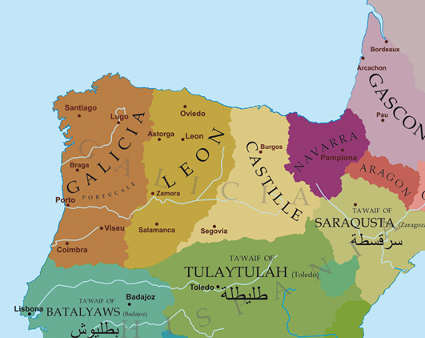

Generated Question - Which kingdom's nobility, linked to Alfonso VI of Leon, controlled the region between the Minho and Douro rivers shown on the map?

Generated Answer - The kingdom of León.

--- Entry for custom_id: d5d115100dba11ecb1e81171463288e9 ---

Example Question - Which more clearly defines a belief that just about anything has a spirit; Religion or Animism?

Example Answer - Animism

Image Source 1 -



Generated Question - How does animism differ from general religion in its view of spiritual essence in objects and creatures?

Generated Answer - Animism uniquely believes all objects and creatures possess a distinct spiritual essence, unlike general religion.

--- Entry for custom_id: d5dc26bc0dba11ecb1e81171463288e9 ---

Example Question - What is the more common form of hermaphroditism of producing reproductive cells at different life stages, where a born female changes into a male some time?

Example Answer - Protogynous hermaphrodites.

Image Source 1 -



Generated Question - How do earthworms differ from protogynous hermaphrodites in their reproductive organ development?

Generated Answer - Earthworms are simultaneous hermaphrodites with both organs at once, while protogynous hermaphrodites change from female to male.

--- Entry for custom_id: d5c88f760dba11ecb1e81171463288e9 ---

Image Source 1 -

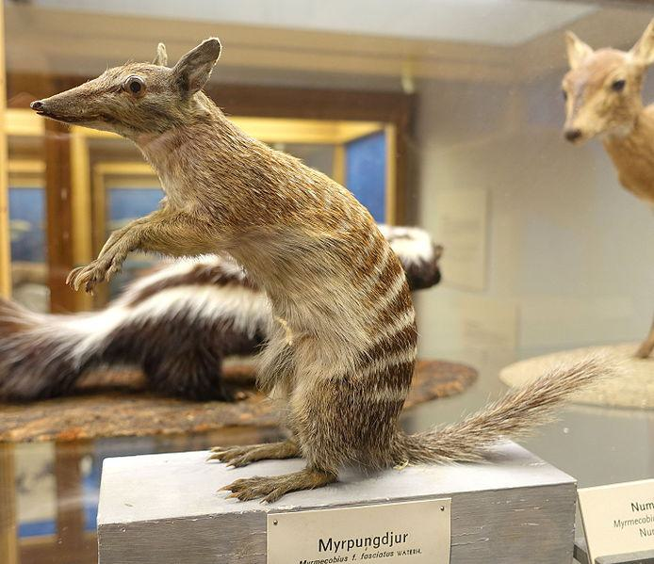

Caption for image source 1: Myrmecobius fasciatus - Swedish Museum of Natural History - Stockholm, Sweden - DSC00656 Exhibit in the Swedish Museum of Natural History - Stockholm, Sweden. Photography was permitted in the museum without restriction..

Image Source 2 -



Caption for image source 2: Siberian Chipmunk (Tamias sibiricus), Parc du Rouge-Cloître, Forêt de Soignes, Brussels (26040359560).

Example Question - "Is the snout of the Siberian Chipmunk longer relative to its body than the snout of the Myrmecobius Fasciatus?"

Example Answer - "No, the snout of the Siberian Chipmunk is not longer relative to its body than the snout of the Myrmecobius Fasciatus."

Additional Text Source 1 - Two subspecies have been described, but one of these—the rusty coloured Myrmecobius fasciatus rufus Finlayson, 1933,—has been extinct since at least the 1960s, and only the nominate subspecies (M. fasciatus fasciatus) remains alive today. The population described by Finlayson occurred in the arid central regions of South Australia, and he thought they had once extended to the coast. (from: Numbat)

Generated Question - Considering the extinction of one subspecies, does the Myrmecobius fasciatus in the museum exhibit represent the currently surviving subspecies?

Generated Answer - Yes, the museum exhibit represents the surviving nominate subspecies of Myrmecobius fasciatus.

--- Entry for custom_id: d5c2ab420dba11ecb1e81171463288e9 ---

Image Source 1 -



Caption for image source 1: WardenT&T T & T at Warden Centre in Markham.

Example Question - "What colors are used for the lettering sign on the front of the T&T Supermarket building in Markham?"

Example Answer - "The lettering on the sign for the T&T Supermarket in Markham is red, white, and green."

Additional Text Source 1 - The company's supermarket brands are Lianhua Supermarket and Hualian Supermarket (S: 华联超市, T: 華聯超市, P: Huálián Chāoshì). Its convenience store brand is Lianhua Quik (C: 快客便利, P: Kuàikè Biànlì). (from: Lianhua Supermarket)

Generated Question - Are the T&T Supermarket in Markham and the Lianhua Supermarket brands likely to share similar signage colors based on the image and text sources?

Generated Answer - No, the T&T Supermarket uses green, red, and white, while Lianhua Supermarket's colors are not specified.

--- Entry for custom_id: d5c11ab60dba11ecb1e81171463288e9 ---

Image Source 1 -



Caption for image source 1: NNC-US-1796-G$2½-Turban Head (no stars) 1796 G$2 Turban Head (or Capped Bust) (no stars)Gold (fineness 0.9160), 20mm, 4.37g, designed by Robert ScotJN2015-6714-15.

Example Question - "Does the head on the Turban Head coin have long or short hair?"

Example Answer - "The head on the Turban Head coin has long hair."

Additional Text Source 1 - Arousal by head hair may arise from seeing or touching very long or short hair, wet hair, a certain color of hair or a particular hairstyle. Others may find the attraction of literally "having sex with somebody's hair" as a fantasy or fetish. (from: Hair fetishism)

Generated Question - Does the Turban Head coin depict long hair that could be associated with hair attraction or fetishism?

Generated Answer - Yes, the Turban Head coin depicts long hair that could be linked to hair attraction.

--- Entry for custom_id: d5cd57d60dba11ecb1e81171463288e9 ---

Image Source 1 -

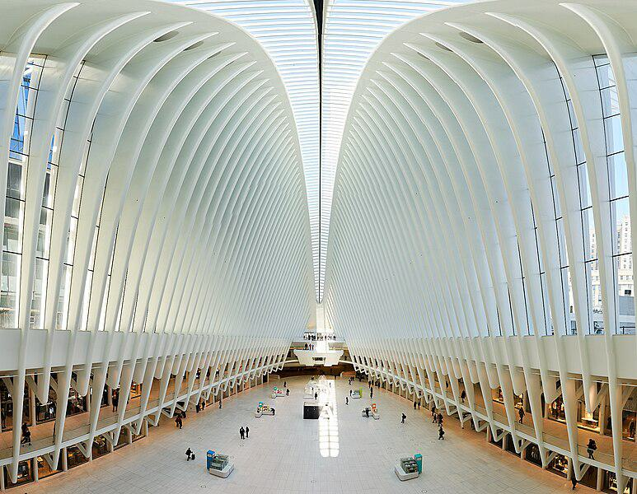

Caption for image source 1: Westfield Mall The Westfield Mall in One World Trade Center in New York CIty..

Example Question - "Are all the white ribs in the Westfield Mall in One World Trade Center in New York City the same length?"

Example Answer - "No, all of the white ribs in the Westfield Mall in the One World Trade Center in New York City do not have the same length."

Additional Text Source 1 - One World Trade Center (also known as One World Trade, One WTC, and formerly Freedom Tower) is the main building of the rebuilt World Trade Center complex in Lower Manhattan, New York City. One WTC is the tallest building in the United States, the tallest building in the Western Hemisphere, and the sixth-tallest in the world. (from: One World Trade Center)

Generated Question - Is the Westfield Mall located inside the tallest building in the United States?

Generated Answer - Yes, the Westfield Mall is inside One World Trade Center, the tallest building in the United States.

--- Entry for custom_id: d5ca8dda0dba11ecb1e81171463288e9 ---

Image Source 1 -

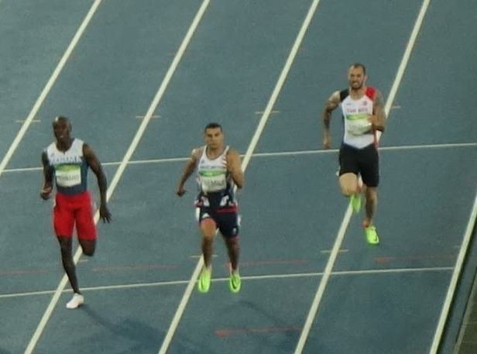

Caption for image source 1: Men's 200 metres event at the 2016 Summer Olympics, Olympic Stadium (Engenhão), Rio de Janeiro, Brazil (cropped) Men's 200 metres event at the 2016 Summer Olympics, Olympic Stadium (Engenhao), Rio de Janeiro, Brazil..

Image Source 2 -

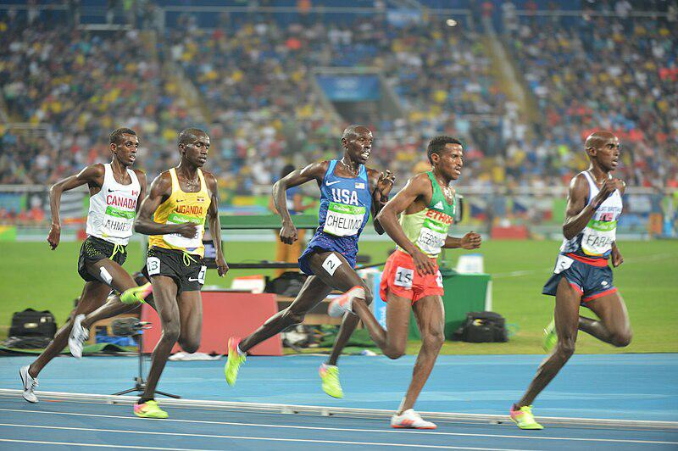

Caption for image source 2: Spc. Paul Chelimo wins silver medal in 5,000 meters at Rio Olympic Games photos by Tim Hipps, IMCOM Public Affairs (29090421706).

Example Question - "In the 5,000 and 200 meters events at the Rio Olympic Games, did the athletes wear their country's name across their chest?"

Example Answer - "Yes, they wore their country's name across their chest."

Additional Text Source 1 - He previously participated in two other Olympic games and three events (The men's 400 meters and men's 4 x 400 meters relay in Sydney, and the men's 400 meters hurdles in Athens), winning silver medals in the Sydney relay and the Athens hurdles race. During the August 15 qualifications, McFarlane participated in the second heat against five other athletes. (from: Jamaica at the 2008 Summer Olympics)

Generated Question - Did athletes in both the 200 meters and 5,000 meters events at the Rio Olympics wear bib numbers on their uniforms?

Generated Answer - Yes, athletes in both events wore bib numbers on their uniforms.

--- Entry for custom_id: d5c43bec0dba11ecb1e81171463288e9 ---

Image Source 1 -

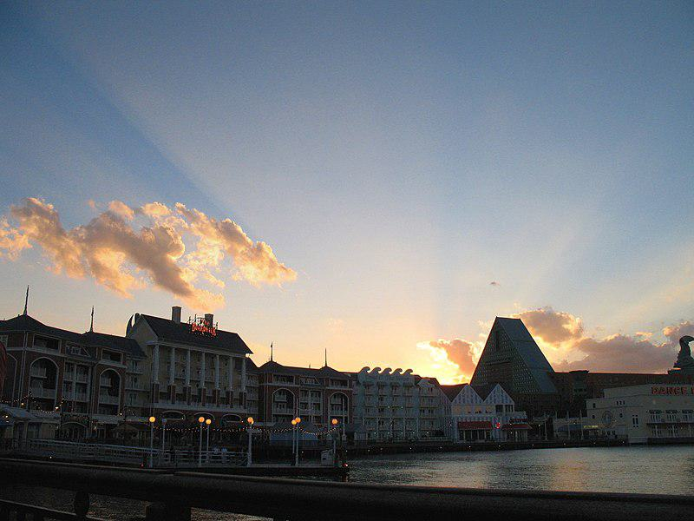

Caption for image source 1: DISNEYWORLD BOARDWALK RESORT - panoramio.

Image Source 2 -



Caption for image source 2: Coronado Blue (33706136420).

Example Question - "Are Disney's Coronado Springs Resort and Disneyworld's Boardwalk Resort both located on the water?"

Example Answer - "Yes, Disney's Coronado Springs Resort and Disneyworld's Boardwalk Resort are both located on the water."

Additional Text Source 1 - About two years after the initial release, The Walt Disney World Explorer – Second Edition was released with updated information on new attractions, parks, and resorts (e.g. Buzz Lightyear's Space Ranger Spin, Disney's Animal Kingdom, and Disney's Coronado Springs Resort). The application is narrated by Hettie Lynne Hurtes and Corey Burton. (from: The Walt Disney World Explorer)

Generated Question - Are both Disney's Coronado Springs Resort and Disneyworld's Boardwalk Resort featured in The Walt Disney World Explorer's updated edition?

Generated Answer - Yes, both resorts are featured in The Walt Disney World Explorer's updated edition.

--- Entry for custom_id: d5d1f34a0dba11ecb1e81171463288e9 ---

Example Question - What literature has a number of Germanic gods mentioned in it that can include Týr and Ullr?

Example Answer - Old Norse.

Image Source 1 -

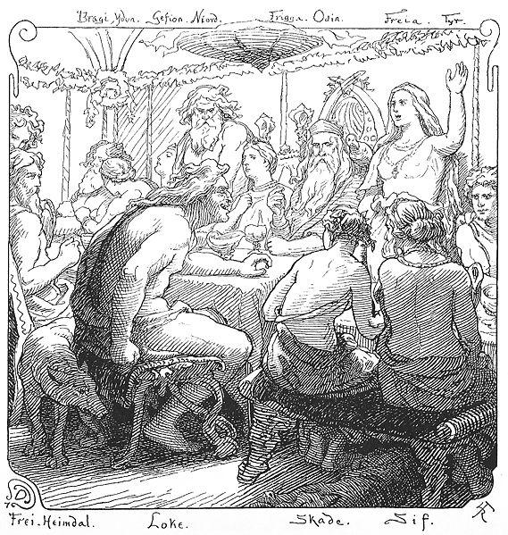

Generated Question - Which group of Germanic gods, including Týr, is primarily associated with war and mentioned in Old Norse literature?

Generated Answer - The Æsir are primarily associated with war and include Týr in Old Norse literature.

--- Entry for custom_id: d5ccad4a0dba11ecb1e81171463288e9 ---

Image Source 1 -

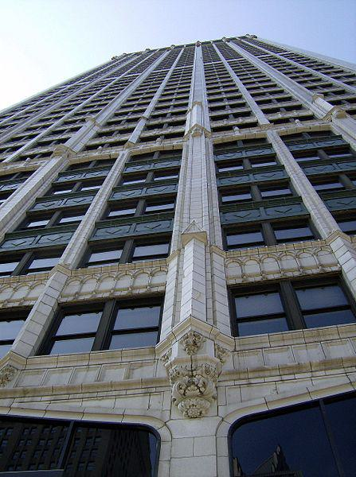

Caption for image source 1: CadillaclookingupDetroit Cadillac Tower in Detroit, Michigan, United States..

Image Source 2 -

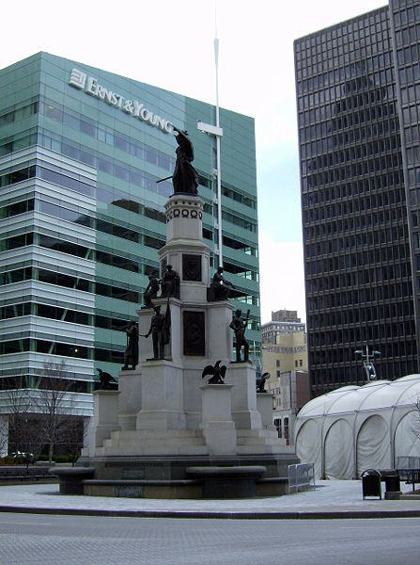

Caption for image source 2: MichiganSoldiersSailors.

Example Question - "Is the Stone on the Michigan Soldiers & Sailors Monument the same Shade of Grey as the facade of the Cadillac building in Detroit?"

Example Answer - "No, the Stone on the Michigan Soldiers & Sailors Monument is not the same Shade of Grey as the facade of the Cadillac building in Detroit."

Additional Text Source 1 - Confederate Soldiers and Sailors Monument, Garfield Park, erected, according to its inscription, "to mark the burial place of 1616 Confederate soldiers and sailors who died here as prisoners of war and whose graves cannot now be identified. " Following protests of the murder of George Floyd in June 2020, the city announced plans to remove the monument. (from: List of Confederate monuments and memorials)

Generated Question - Are the Michigan Soldiers & Sailors Monument and the Confederate Soldiers and Sailors Monument both planned for removal due to protests?

Generated Answer - No, only the Confederate Soldiers and Sailors Monument is planned for removal.

--- Entry for custom_id: d5d5bade0dba11ecb1e81171463288e9 ---

Example Question - Libor which is calculated by the Intercontinental Exchange stands for what?

Example Answer - London Inter-bank Offered Rate

Image Source 1 -



Generated Question - Is the name Libor in Libor Šulák related to the financial term LIBOR calculated by the Intercontinental Exchange?

Generated Answer - No, Libor Šulák is a person's name and unrelated to the financial LIBOR index.

--- Entry for custom_id: d5dfa6d40dba11ecb1e81171463288e9 ---

Example Question - The method of modeling what, which in biology is the similarity due to shared ancestry between a pair of structures or genes in different taxa, is based on the observation that protein tertiary structure is better conserved than amino acid sequence?

Example Answer - homology

Image Source 1 -



Generated Question - How does the sequence alignment of mammalian histone proteins illustrate the principle that protein tertiary structure is better conserved than amino acid sequence in homology modeling?

Generated Answer - The alignment shows conserved and mutated residues, indicating structural conservation despite sequence variation.

--- Entry for custom_id: d5d13d100dba11ecb1e81171463288e9 ---

Example Question - Which operated in a wider market: American Association of Professional Baseball or United League Baseball?

Example Answer - American Association of Professional Baseball operated in a wider market.

Image Source 1 -



Generated Question - Which baseball league operated earliest among United League Baseball, American Association of Professional Baseball, and the All-American Girls Professional Baseball League?

Generated Answer - The All-American Girls Professional Baseball League operated earliest, in 1948.

--- Entry for custom_id: d5c7276c0dba11ecb1e81171463288e9 ---

Image Source 1 -

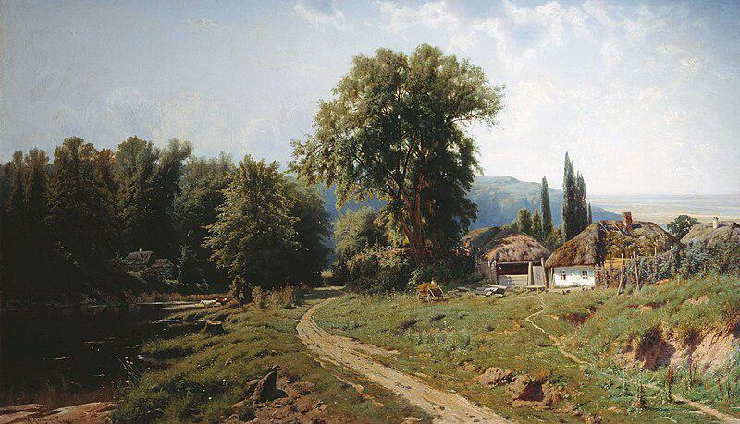

Caption for image source 1: KonstantinKryzhitsky HutorVMalorossii 1884 Khutir (or hamlet) in Little Russia, 1884.

Example Question - "What material is the roof of the house in Constantin Kryjitski's "Khutir (or hamlet) in Little Russia, 1884" made from?"

Example Answer - "The roof of the house is thatched in Constantin Kryjitski's "Khutir (or hamlet) in Little Russia, 1884."

Additional Text Source 1 - Prilepin said in an interview that the rationale behind the proposed state was that the separatists no longer could be called such because they were now supporting a unified state. On 9 August, Zakharchenko stated that the proposed state would not be named "Malorossiya" ("Little Russia") because "many feel repulsed by" the name. (from: Little Russia)

Generated Question - Does the name "Malorossiya" in the painting's title relate to the proposed state's name mentioned by Zakharchenko?

Generated Answer - No, Zakharchenko said the proposed state would not be named "Malorossiya" due to negative feelings.

--- Entry for custom_id: d5d17d980dba11ecb1e81171463288e9 ---

Example Question - Does the auriculotemporal nerve run parallel to the superficial iliac circumflex artery?

Example Answer - No, the superficial iliac circumflex artery is in the leg and the auriculotemporal nerve is in the head.

Image Source 1 -

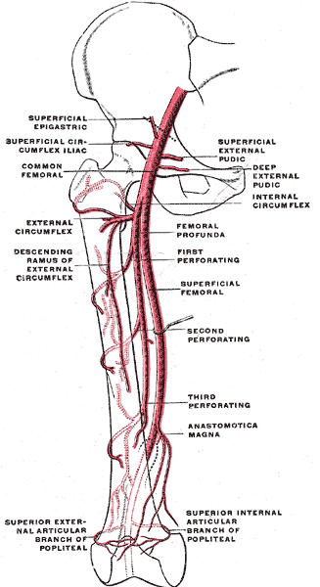

Generated Question - Are the superficial circumflex iliac artery and the auriculotemporal nerve both branches of arteries in the thigh region?

Generated Answer - No, the superficial circumflex iliac artery is in the thigh, but the auriculotemporal nerve is in the head.

--- Entry for custom_id: d5d0c7220dba11ecb1e81171463288e9 ---

Example Question - What is the basic difference between the reflectivity on individual PPI angles and composite reflectivity?

Example Answer - The reflectivity on individual PPI angles show the precipitation intensity at that specific angle above the horizon while the composite reflectivity is the maximum dBZ reflectivity from any of the reflectivity angles of the NEXRAD weather radar

Image Source 1 -

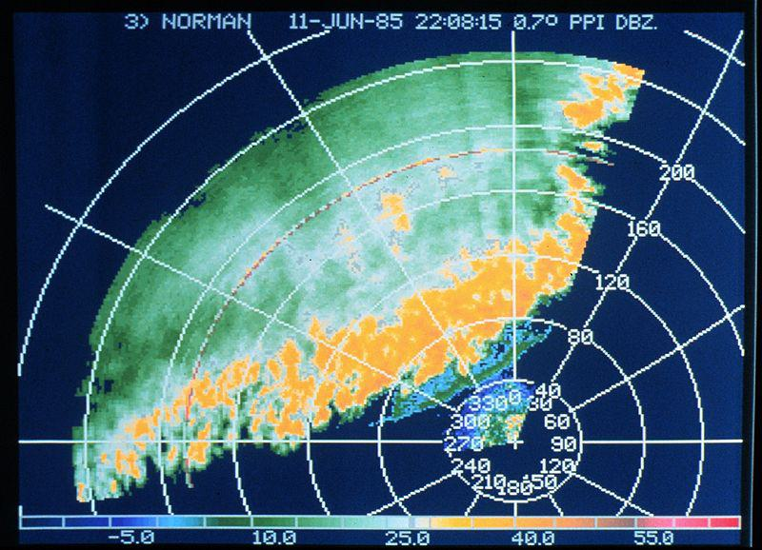

Generated Question - How does the reflectivity shown in the thunderstorm line image relate to the individual PPI angles described in the text?

Generated Answer - The image shows precipitation intensity at a specific PPI angle, reflecting the concept of individual PPI angle reflectivity.

--- Entry for custom_id: d5c95f6e0dba11ecb1e81171463288e9 ---

Image Source 1 -

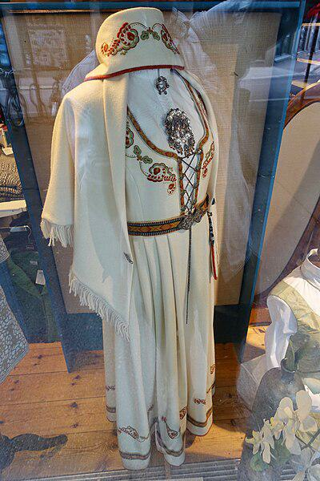

Caption for image source 1: Vestfoldbunad Den broderte Segerbrandt-bunaden For sale at Vestfold-Stua in Tønsberg, Norway (reconstructed traditional folk costume of Vestfold county with embroidery) 2019-08-27 5281 Brodert vestfoldbunad / Segerbrandt-bunaden; Norwegian bunad (reconstructed traditional/folk costume) of Vestfold County, model with embroidery designed by Petrine Segerbrandt (born 1880), for sale at Vestfold-Stua women's clothing store in Tnsberg, Norway..

Image Source 2 -



Caption for image source 2: Amerindian woman in her traditional clothes.png photo of an amerindian woman in her traditional clothes.

Example Question - "Can floral designs be found in both the traditional folk costume of Vestfold county, Norway and traditional Amerindian women clothing?"

Example Answer - "Yes, floral designs can be found in both the traditional folk costume of Vestfold county, Norway and traditional Amerindian women clothing."

Additional Text Source 1 - Some speakers make a sharp break between traditional folk costume (tracht) and the "dirndl", a word which they use only for modern designs. For instance, tracht scholar Thekla Weissengruber distinguishes between renewed tracht (based closely upon historical designs) and Trachtenbekleidung (tracht clothing), including dirndls and lederhosen. (from: Dirndl)

Generated Question - Do both the Vestfoldbunad and traditional Amerindian clothing represent renewed traditional designs rather than modern fashion adaptations?

Generated Answer - Yes, both represent renewed traditional designs rooted in cultural heritage.

--- Entry for custom_id: d5cc2ab40dba11ecb1e81171463288e9 ---

Image Source 1 -



Caption for image source 1: BMLRR City Point Trestle (MP 2.0) BML#50 and BML#53, a pair of late 1940's GE 70-ton diesel electric locomotives, crossing the BML's City Point Trestle (MP 2.0) at the "Head of Tide" heading inland from Belfast, Maine, on the 33-mile Belfast and Moosehead Lake Railroad main line to Burnham Junction..

Example Question - "What runs under the train tracks on the BML's City Point Trestle?"

Example Answer - "Water runs under the train tracks on the BML's City Point Trestle."

Additional Text Source 1 - He cites a book called "Senro wa tsuzuku" (The Tracks Go On And On), a book loved by his son, for inspiring the inclusion of a train. He discusses how in the book, children construct railroad tracks, also doing things such as creating tunnels or bridges when they find mountains or rivers. (from: The Legend of Zelda: Spirit Tracks)

Generated Question - How does the BML's City Point Trestle relate to the idea of building bridges over water as inspired by the book mentioned?

Generated Answer - The BML's City Point Trestle is a bridge over water, similar to how children build bridges over rivers in the book.

--- Entry for custom_id: d5c2c5640dba11ecb1e81171463288e9 ---

Image Source 1 -

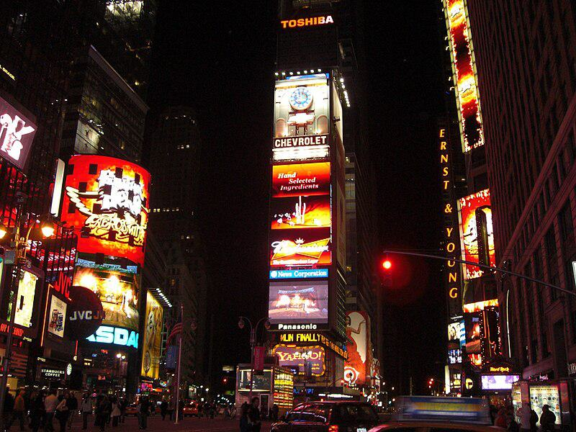

Caption for image source 1: Times Square, New York, USA1 Times Square, New York, USA.

Example Question - "Does Times Square feature ads from Chevrolet?"

Example Answer - "Chevrolet ads are featured in Times Square."

Additional Text Source 1 - The tower was originally built to serve as the headquarters of The New York Times, which moved into the tower in January 1904. The paper's owner persuaded the city to re-name the area "Times Square". (from: One Times Square)

Generated Question - Is the name "Times Square" related to the original purpose of the tower shown in the image?

Generated Answer - Yes, the tower was the New York Times headquarters, inspiring the name "Times Square".

--- Entry for custom_id: d5de28a40dba11ecb1e81171463288e9 ---

Example Question - For the individual who discovered the law of gravitation, what did his writings suggest towards the main goals of alchemy?

Example Answer - Discovery of the philosopher's stone and Elixir of Life.

Image Source 1 -

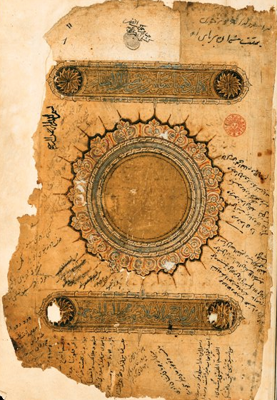

--- Entry for custom_id: d5c789820dba11ecb1e81171463288e9 ---

Image Source 1 -

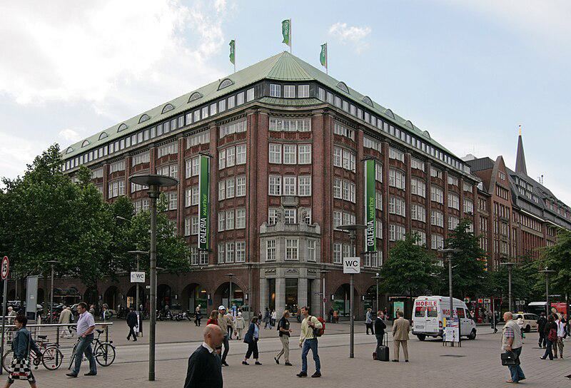

Caption for image source 1: Galeria Kaufhof Hamburg Galeria Kaufhof im Klopperhaus an der Monckebergstrae in Hamburg-Altstadt..

Example Question - "How many flags are atop the Galeria Kaufhof Hamburg?"

Example Answer - "There are three flags atop the Galeria Kaufhof Hamburg."

Additional Text Source 1 - Jewish-owned department stores were confiscated from their owners during the Nazi regime. Next to some smaller, independent department stores like Breuninger in Stuttgart these are Karstadt (in 2010 taken over by Nicolas Berggruen, also operating the KaDeWe and the Kaufhof at Alexanderplatz in Berlin, the Alsterhaus in Hamburg and the Oberpollinger Oberpollinger in Munich, and Galeria Kaufhof. (from: Department stores by country)

Generated Question - Is the Galeria Kaufhof in Hamburg part of a group of department stores that includes Karstadt and Alsterhaus?

Generated Answer - Yes, Galeria Kaufhof in Hamburg is part of the group that includes Karstadt and Alsterhaus.

--- Entry for custom_id: d5d9d22c0dba11ecb1e81171463288e9 ---

Example Question - What were the Messerschmitt Bf 109 and 152 air aces from Canada involved in?

Example Answer - World War II.

Image Source 1 -

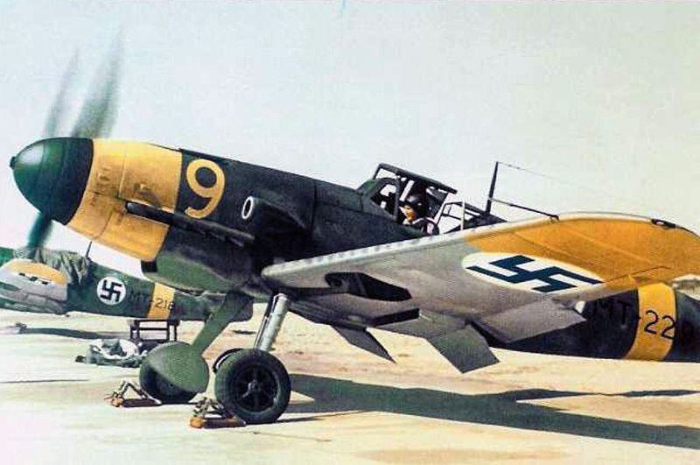

Generated Question - Were the Messerschmitt Bf 109 and the Canadian and Chinese fighter aces all involved in the same war?

Generated Answer - Yes, they were all involved in World War II.

--- Entry for custom_id: d5cb1c8c0dba11ecb1e81171463288e9 ---

Image Source 1 -



Caption for image source 1: 2011-06-15 Mycena sanguinolenta (Alb. & Schwein.) P. Kumm 151560.

Example Question - "Do the caps on the Mycena sanguinolenta have bumps?"

Example Answer - "The caps on the Mycena sanguinolenta have bumps."

Additional Text Source 1 - The other "bleeding Mycena" (M. haematopus) is readily distinguished from M. sanguinolenta by its larger size, different color, growth on rotting wood, and presence of a sterile band of tissue on the margin of the cap. Further, M. sanguinolenta consistently has red-edged gills, while the gill edges of M. haematopus are more variable. (from: Mycena sanguinolenta)

Generated Question - Can Mycena sanguinolenta be identified by its size and growth on rotting wood compared to Mycena haematopus?

Generated Answer - No, Mycena sanguinolenta is smaller and does not grow on rotting wood like Mycena haematopus.

--- Entry for custom_id: d5c72fb40dba11ecb1e81171463288e9 ---

Image Source 1 -

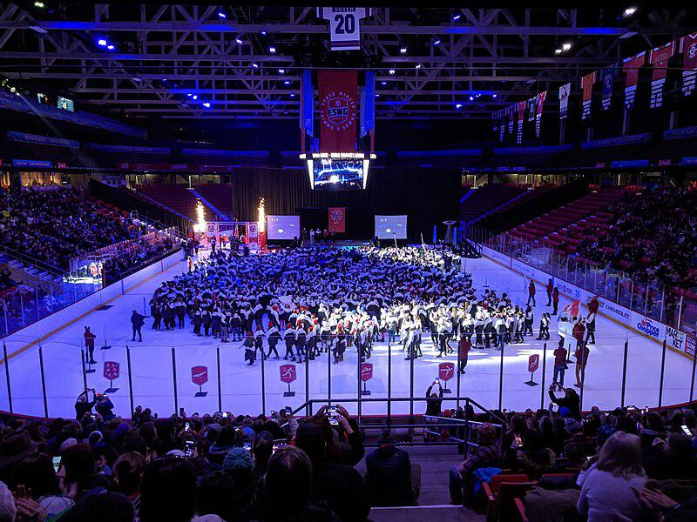

Caption for image source 1: EmpireStateWinterGames2020OpeningCeremony Opening ceremony for the 2020 Empire State Winter Games in the Olympic Center.

Example Question - "How many big screens surround the stage on the ice rink at the 2020 Empire State Winter Games opening ceremony?"

Example Answer - "There were three big screens surrounding the stage on the ice rink at the 2020 Empire State Winter Games opening ceremony."

Additional Text Source 1 - " Writing in The Observer, Jackie Kay commented that "it seemed that Boyle had invented a new kind of opening ceremony, a concept ceremony, one that embraces big ideas as passionately as it does technical flamboyancy". The Stage said that "Danny Boyle's spectacular and moving Olympics Opening Ceremony was undoubtedly the theatrical highlight of 2012". (from: 2012 Summer Olympics opening ceremony)

Generated Question - How does the 2020 Empire State Winter Games opening ceremony on ice compare to Danny Boyle's 2012 Olympics opening ceremony in terms of embracing big ideas and technical flamboyance?

Generated Answer - The 2020 Empire State Winter Games opening ceremony is a large, organized event on ice, while Danny Boyle's 2012 ceremony was praised for its big ideas and technical flamboyance.

--- Entry for custom_id: d5d62f3c0dba11ecb1e81171463288e9 ---

Example Question - The sticky emu bush was first formally described in what year?

Example Answer - Eremophila glutinosa was first formally described by Robert Chinnock in 1979.

Image Source 1 -



Generated Question - Does the sticky emu bush have resinous leaves and where is it typically found growing?

Generated Answer - Yes, it has sticky resinous leaves and grows on rocky hills and granite outcrops in Western Australia.

--- Entry for custom_id: d5d1eb660dba11ecb1e81171463288e9 ---

Example Question - Was the NASCAR Winston Cup Series or the NASCAR Busch Series longer in 1992?

Example Answer - The Winston Cup was longer than the Busch Series.

Image Source 1 -



Generated Question - Did the 1992 NASCAR Winston Cup Series or the Winston West Series, where Kevin Harvick drove in 1997, start earlier in the year?

Generated Answer - The 1992 NASCAR Winston Cup Series started earlier in the year than the 1997 Winston West Series.

--- Entry for custom_id: d5cc4d500dba11ecb1e81171463288e9 ---

Image Source 1 -

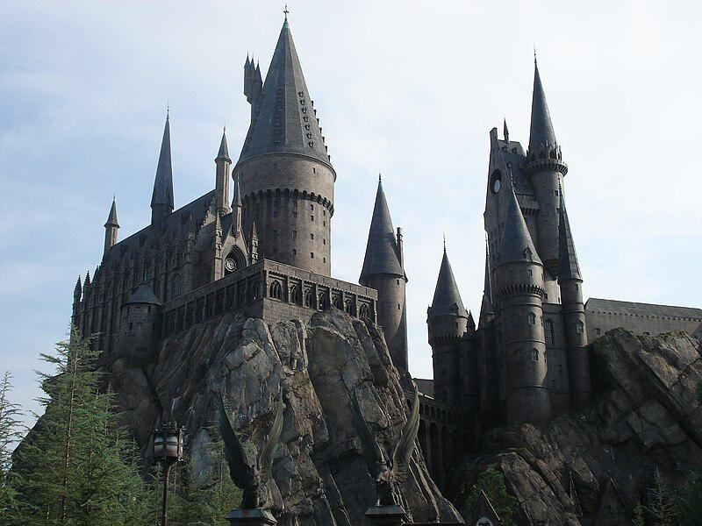

Caption for image source 1: Hogwarts's replica in Universal Studio, Orlando Hogwarts's replica in Universal Studio, Orlando.

Example Question - "What shape is the base of the tallest tower in Hogwarts's replica castle at Universal Studio?"

Example Answer - "It is a circle."

Additional Text Source 1 - The CN Tower was surpassed in 2009 by the Canton Tower in Guangzhou, China, which stands at 604 metres (1,982 ft) tall, as the world's tallest tower; which in turn was surpassed by the Tokyo Skytree in 2011, which currently is the tallest tower at 634.0 metres (2,080.1 ft) in height. (from: CN Tower)

Generated Question - Is the tallest tower in Hogwarts's replica castle taller or shorter than the CN Tower?

Generated Answer - The tallest tower in Hogwarts's replica castle is much shorter than the CN Tower.

--- Entry for custom_id: d5db09da0dba11ecb1e81171463288e9 ---

Example Question - Eel and South Fork American are both names of what?

Example Answer - Rivers

Image Source 1 -



Generated Question - Which South Fork river flows through a wilderness area shown on the map, and which one flows through the Sierra Nevada foothills?

Generated Answer - South Fork Eel River flows through wilderness shown on the map; South Fork American River flows through Sierra Nevada foothills.

--- Entry for custom_id: d5c9dd7c0dba11ecb1e81171463288e9 ---

Image Source 1 -

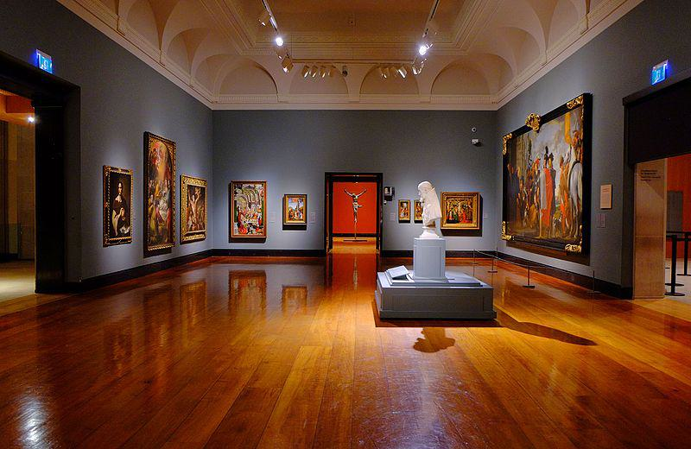

Caption for image source 1: Art Gallery of Ontario (23782351913).

Example Question - "What kind of lighting can be found in the Ontario Art Gallery?"

Example Answer - "Ceiling track lighting can be found in the Ontario Art Gallery."

Additional Text Source 1 - True North Gallery (also known as The Music Gallery of Fine Art), founded in 2016 by Geoff and Brooke Kulawick, is an art museum and gallery in downtown Waterdown, Ontario, Canada. Dedicated to showcasing visual art by professional musicians, it claims to be the only art gallery of its kind. (from: True North Gallery)

Generated Question - How does the Art Gallery of Ontario's lighting compare to the typical setting of the True North Gallery in Ontario?

Generated Answer - The Art Gallery of Ontario uses ceiling track lighting, while the True North Gallery focuses on visual art by musicians without specified lighting.

--- Entry for custom_id: d5cf130a0dba11ecb1e81171463288e9 ---

Image Source 1 -



Caption for image source 1: University Club, Virginia Tech The University Club at Virginia Tech in Blacksburg, Virginia.

Example Question - "What color are the awnings over the entryway into the University Club at Virginia Tech?"

Example Answer - "The awnings over the entryway into the University Club at Virginia Tech are green."

Additional Text Source 1 - University of Waterloo sociology professor Kenneth Westhues criticized both the university's response to the shootings and the Massengill Report. Westhues identified the cause of the shootings as a mobbing Cho had experienced in the Virginia Tech English department and suggested that the explanation for Cho's actions should go beyond what he calls the "defective character" explanation: (from: Virginia Tech shooting)

Generated Question - How does the additional text source relate to the University Club at Virginia Tech shown in the image?

Generated Answer - The text discusses a shooting incident linked to Virginia Tech, where the University Club is located.

--- Entry for custom_id: d5c1bd900dba11ecb1e81171463288e9 ---

Image Source 1 -

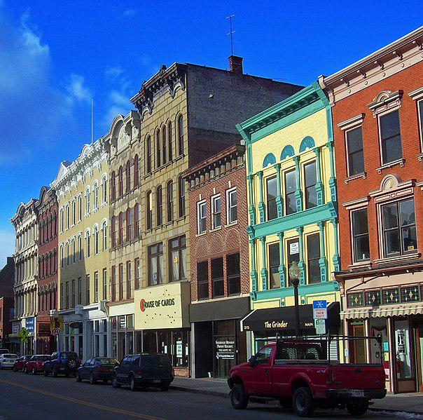

Caption for image source 1: Main Mall Row, Poughkeepsie, NY.

Image Source 2 -

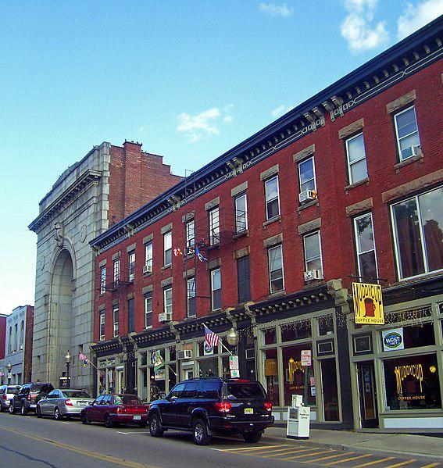

Caption for image source 2: Lower Main Street, Beacon, NY.

Example Question - "Does the Main Mall Row in Poughkeepsie, NY or the Lower Main Street building complex in Beacon, NY have a more colorful facade?"

Example Answer - "The Main Mall Row in Poughkeepsie, NY has a more colorful facade."

Additional Text Source 1 - Lafuente had a plan to revitalize the City of Poughkeepsie by a process that would replace blighted areas with new housing and businesses. A native to the area, Lafuente had an intention to plant the seeds that would return Main Street to its prominence and such a plan would involve the elimination of the Main Mall. (from: Main Mall)

Generated Question - Considering Lafuente's plan to revitalize Poughkeepsie, which area between Main Mall Row and Lower Main Street is more likely targeted for redevelopment due to its current appearance?

Generated Answer - Main Mall Row is more likely targeted for redevelopment due to its colorful but older facade.

--- Entry for custom_id: d5ca4bf40dba11ecb1e81171463288e9 ---

Image Source 1 -

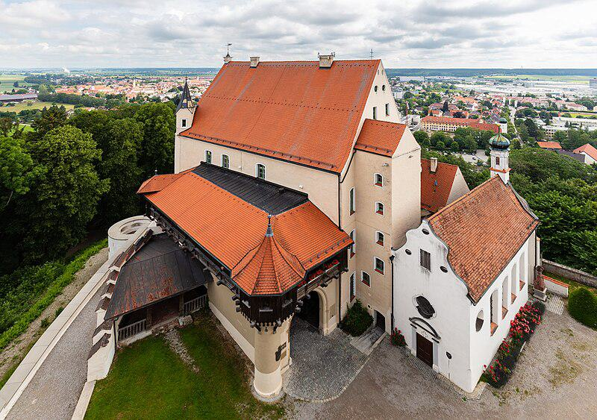

Caption for image source 1: Castillo Mindelburg, Mindelheim, Alemania, 2019-06-21, DD 31 Mindelburg Castle, Mindelheim, Germany.

Image Source 2 -

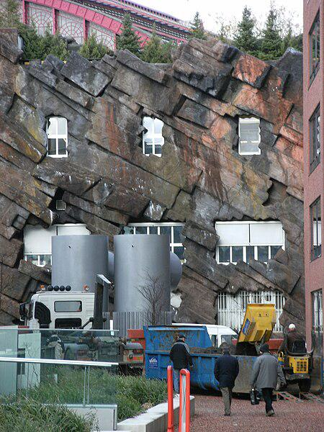

Caption for image source 2: Strange building with fake rock formations Antwerpen Strange building with fake rock formations Antwerpen..

Example Question - "What grows near both a Strange building with fake rock formations in Antwerpen and Mindelburg Castle?"

Example Answer - "Grass grows near both a Strange building with fake rock formations in Antwerpen and Mindelburg Castle."

Additional Text Source 1 - Last month he tweeted about "fake books," "the fake dossier," "fake CNN," and he added a new claim—that Google search results are "RIGGED" to mostly show only negative stories about him. " They graphed his expanding use in columns labeled: "Fake news", "Fake (other) and "Phony". (from: Fake news)

Generated Question - How do the concepts of "fake" in the additional text relate to the physical "fake" elements seen near the buildings in the images?

Generated Answer - Both involve artificial or deceptive elements—fake news in text and fake rock formations near the buildings.

--- Entry for custom_id: d5bfd9760dba11ecb1e81171463288e9 ---

Image Source 1 -

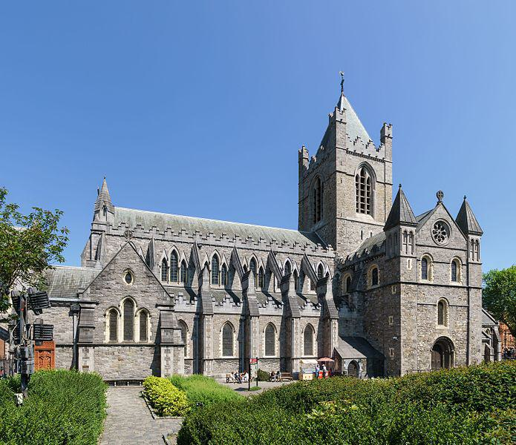

Caption for image source 1: Christ Church Cathedral, Dublin, 2016-06-03 Christ Church Cathedral.

Image Source 2 -

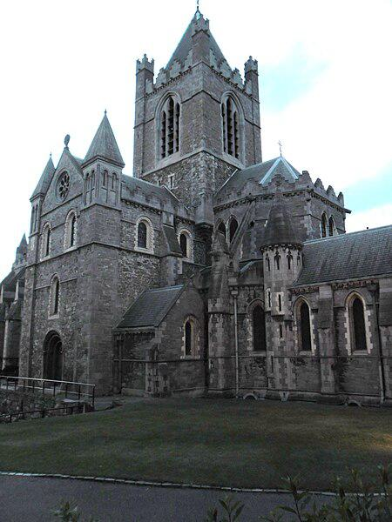

Caption for image source 2: Christ Church Cathedral, Dublin - panoramio.

Example Question - "Does Christ Church Cathedral, Dublin have taller greenery in front or on the sides?"

Example Answer - "The Christ Church Cathedral, Dublin has taller greenery on the sides than in front."

Additional Text Source 1 - In 1971, the general synod, following prior discussions, created the "Christ Church Cathedral Group of Parishes", uniting what were then four parishes with the cathedral, whose dean is their rector: (from: Christ Church Cathedral, Dublin)

Generated Question - Does the Christ Church Cathedral in Dublin have more visible greenery in front or on the sides based on the images and its parish grouping context?

Generated Answer - The Christ Church Cathedral in Dublin has more visible greenery on the sides than in front.

--- Entry for custom_id: d5ce91f00dba11ecb1e81171463288e9 ---

Image Source 1 -

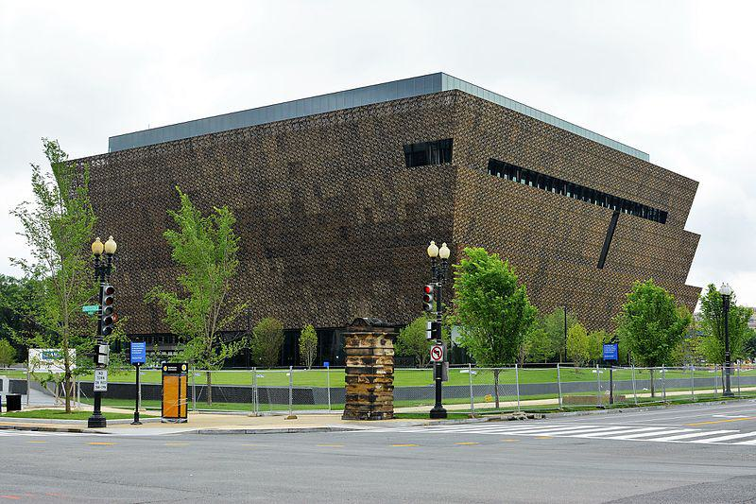

Caption for image source 1: National Museum of African American History and Culture.

Image Source 2 -

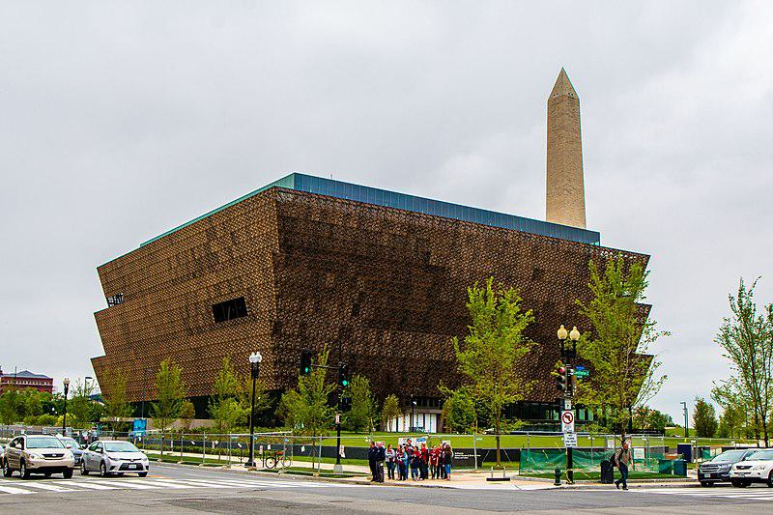

Caption for image source 2: African American Museum Washington, DC The African-American History Museum in Washington, DC.

Example Question - "Are there trees surrounding the African-American History Museum in Washington, DC?"

Example Answer - "Yes, there are trees surrounding the African-American History Museum in Washington, DC."

Additional Text Source 1 - "Field to Factory" encouraged Mack to continue pursuing a museum. In 1987 and 1988, NCEED began lining up support among black members of Congress for legislation that would establish an independent African-American national history museum in Washington, D.C. (from: National Museum of African American History and Culture)

Generated Question - Did the support from black members of Congress in the 1980s contribute to the establishment of the museum surrounded by trees in Washington, D.C.?

Generated Answer - Yes, their support helped establish the National Museum of African American History and Culture surrounded by trees.

--- Entry for custom_id: d5d2efd40dba11ecb1e81171463288e9 ---

Example Question - Which person, who purportedly created abthainries for his brother King Edgar, was called the abbot of Dunkeld?

Example Answer - Ethelred

Image Source 1 -

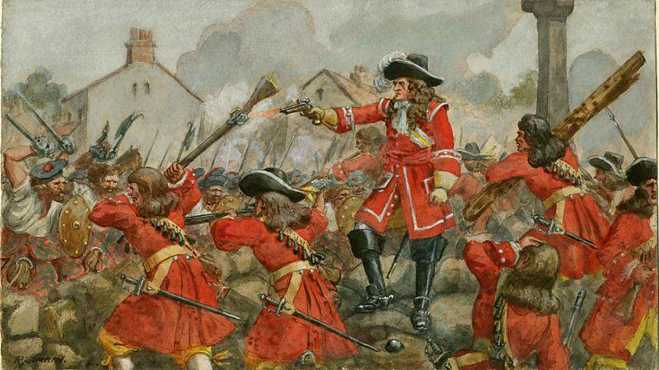

Generated Question - Was Ethelred, who was called abbot of Dunkeld, necessarily a churchman during the time of the Battle of Dunkeld?

Generated Answer - No, Ethelred was not necessarily a churchman but often a layman holding abbacies.

--- Entry for custom_id: d5cc33560dba11ecb1e81171463288e9 ---

Image Source 1 -

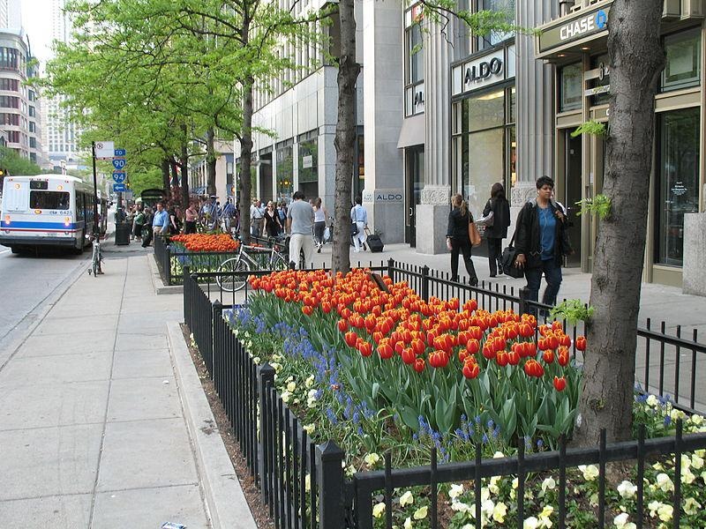

Caption for image source 1: 20070509 Tulip Days 2007 Tulip Days on The Magnificent Mile with CTA bus in view..

Image Source 2 -

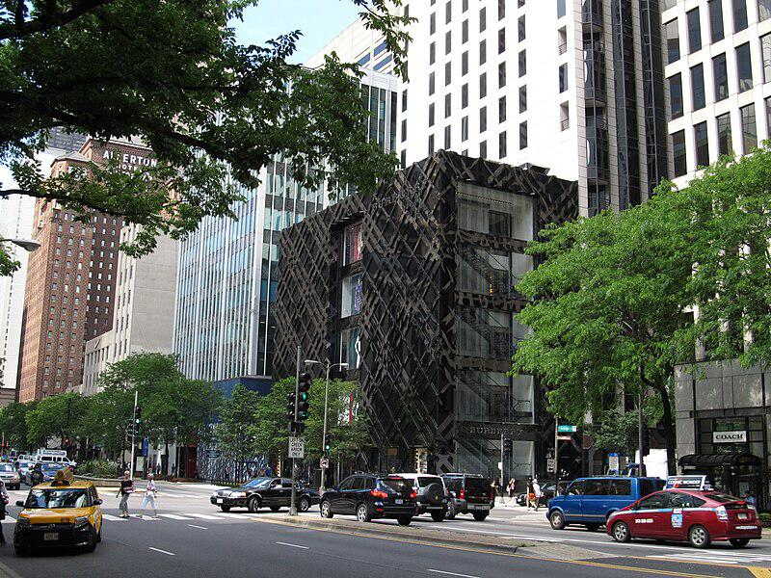

Caption for image source 2: The Magnificent Mile, Michigan Avenue, Chicago, Illinois (9181676490) The Magnificent Mile, sometimes referred to as The Mag Mile, is a prestigious section of Chicago's Michigan Avenue, running from the Chicago River to Oak Street in the Near North Side..

Example Question - "On The Magnificent Mile, what types of transportation service vehicles can be seen?"

Example Answer - "Taxis and buses can be seen on The Magnificent Mile."

Additional Text Source 1 - In 2008, a public art installation of kinetic sculptures designed by local and international architects was placed in the garden beds. During the summer, the "Gardens of The Magnificent Mile" festival event occurs. (from: Magnificent Mile)

Generated Question - Are the flower gardens on The Magnificent Mile decorated with kinetic sculptures during the summer festival?

Generated Answer - Yes, kinetic sculptures are placed in the gardens during the summer festival.

--- Entry for custom_id: d5c283060dba11ecb1e81171463288e9 ---

Image Source 1 -



Caption for image source 1: Jeison Angulo USA-Columbia, FIFA U20 World Cup (18679461162) (cropped).

Image Source 2 -



Caption for image source 2: Philipp Lahm, Germany national football team (06) Philipp Lahm (FC Bayern Munich), german national football team This photograph was taken by user Steindy and released under the license(s) stated below..

Example Question - "Do both FC Bayern Munich and Colombia's national football team wear adidas jerseys?"

Example Answer - "Both the FC Bayern Munich and Colombia's national football team wear Adidas jerseys."

Additional Text Source 1 - Bayern Chairman Karl-Heinz Rummenigge stated, "Of course, Bayern Munich are very angry" with the Royal Dutch Football Association (KNVB), and would be seeking compensation from them, continuing, "Once again we must pay the bill as a club after a player is seriously injured playing for a national team. (from: 2010–11 FC Bayern Munich season)

Generated Question - Do both the Colombia national team player and the Bayern Munich player wear Adidas kits, and does Bayern Munich face issues when their players get injured playing for national teams?

Generated Answer - Yes, both wear Adidas kits, and Bayern Munich is upset about injuries to their players during national team matches.

--- Entry for custom_id: d5c9722e0dba11ecb1e81171463288e9 ---

Image Source 1 -

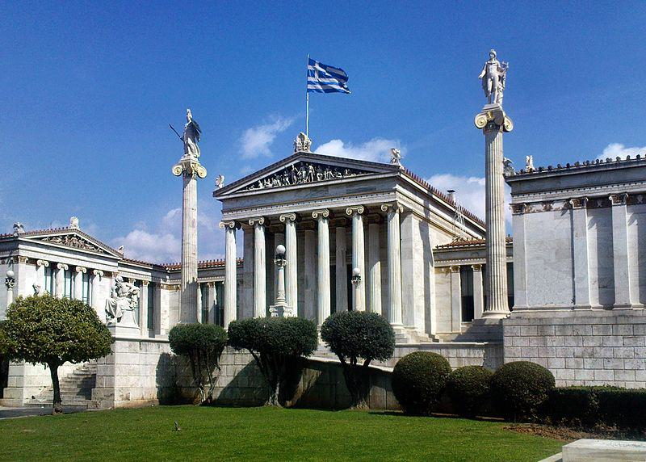

Caption for image source 1: Athens academy Academy of Athens.

Example Question - "At the Academy of Athens how many columns have a statue depicting a human on top of them?"

Example Answer - "Two columns have a statue depicting a human on top of them at the Academy of Athens."

Additional Text Source 1 - Later in the mid and late 19th century, Theophil Freiherr von Hansen and Ernst Ziller took part in the construction of many neoclassical buildings such as the Athens Academy and the Zappeion Hall. Ziller also designed many private mansions in the centre of Athens which gradually became public, usually through donations, such as Schliemann's Iliou Melathron. (from: Athens)

Generated Question - Were the statues on top of the columns at the Academy of Athens likely influenced by neoclassical architects like Theophil Hansen and Ernst Ziller?

Generated Answer - Yes, the statues on the columns reflect the neoclassical style promoted by Hansen and Ziller.

--- Entry for custom_id: d5dbab1a0dba11ecb1e81171463288e9 ---

Example Question - How many years after the death of Ptolemy IV was Arsinoë's defeat by Julius Caesar?

Example Answer - 156 years

Image Source 1 -

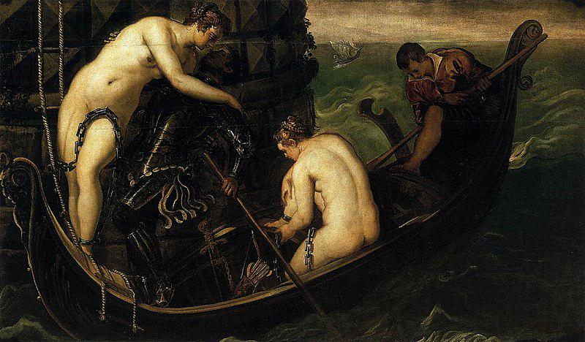

Generated Question - Considering Arsinoë IV's birth range and Ptolemy IV's death, how old was Arsinoë when Ptolemy IV died?

Generated Answer - Arsinoë was not yet born or was an infant when Ptolemy IV died in 204 BC.

--- Entry for custom_id: d5ce857a0dba11ecb1e81171463288e9 ---

Image Source 1 -

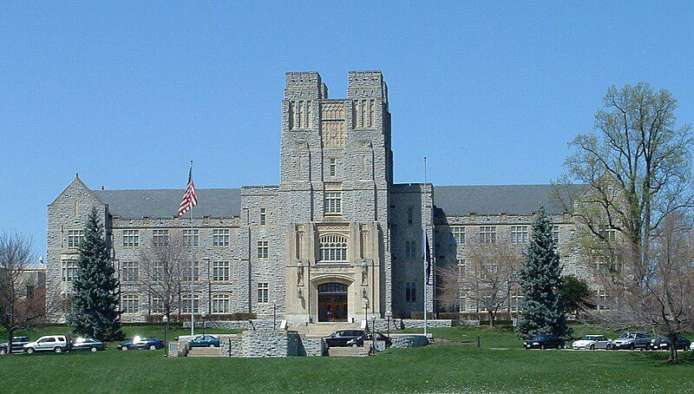

Caption for image source 1: Virginiatech-burrusshall-fromdrillfield Virginia Tech's Burruss Hall taken from the drillfield.

Example Question - "Is Virginia Tech's Burruss Hall symmetrical or asymmetrical?"

Example Answer - "Virginia Tech's Burruss Hall is symmetrical."

Additional Text Source 1 - Opened in August 2012, Turner Place at Lavery Hall is the newest dining hall at Virginia Tech. It features: Atomic Pizzeria, Jamba Juice, 1872 Fire Grill, Qdoba Mexican Grill, Origami (a hibachi grill), Soup Garden, Dolci e Caffe, and Bruegger's Bagels. (from: Campus of Virginia Tech)

Generated Question - Is Burruss Hall's traditional architecture similar to the modern dining options available at Turner Place in Lavery Hall?

Generated Answer - No, Burruss Hall has traditional architecture, while Turner Place offers modern dining options.

--- Entry for custom_id: d5c987960dba11ecb1e81171463288e9 ---

Image Source 1 -



Caption for image source 1: Eighth Avenue Place - East Tower, 2010-09-29.

Image Source 2 -

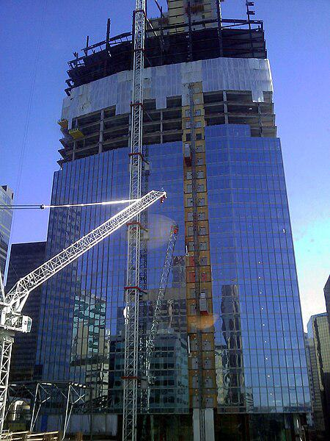

Caption for image source 2: Penny Lane Towers construction Construction of 8th Avenue place (Penny Lane Towers) in April 2010. Calgary, Alberta, Canada.

Example Question - "From which direction were the glass windows installed on the Penny Lane Towers?"

Example Answer - "The glass windows on the Penny Lane Towers were installed from the bottom up."

Additional Text Source 1 - The complex is housed on the site of the former Penny Lane Mall, originally intending to keep the historic name as "Penny Lane Towers", the project has since been renamed. (from: Eighth Avenue Place)

Generated Question - Are the glass windows on Eighth Avenue Place installed in a similar bottom-up manner as seen during Penny Lane Towers construction?

Generated Answer - Yes, the glass windows on Eighth Avenue Place were installed from the bottom up, similar to Penny Lane Towers.

--- Entry for custom_id: d5d8173e0dba11ecb1e81171463288e9 ---

Example Question - Of Gaius Julius Caesar and Trajan, which would have existed further after the death of Jesus?

Example Answer - Trajan would have existed further after.

Image Source 1 -

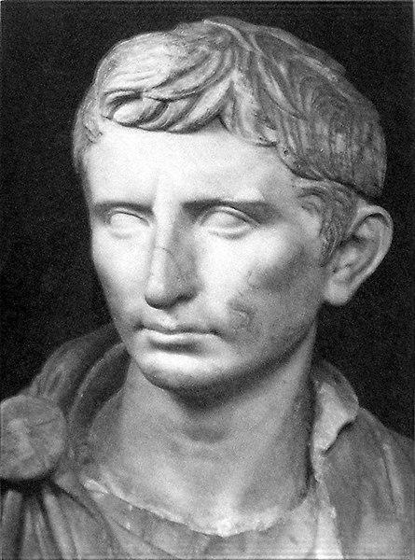

Generated Question - Which Roman leader incorporated the region into Italy first, Gaius Julius Caesar or Trajan?

Generated Answer - Gaius Julius Caesar incorporated the region into Italy first.

--- Entry for custom_id: d5d2aa380dba11ecb1e81171463288e9 ---

Example Question - In the history of Lincolnshire and Lancashire counties, which county was recorded in the Domesday Book?

Example Answer - Lincolnshire was recorded in the Domesday Book as Lindsey, while Lancashire did not exist as a county in the Domesday Book.

Image Source 1 -

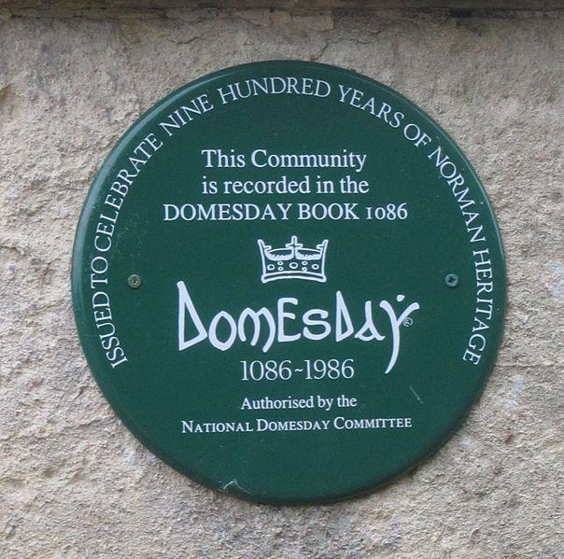

Generated Question - Which county's communities could have memorial plaques like the one shown, based on their recording in the Domesday Book?

Generated Answer - Communities in Lincolnshire (Lindsey) could have such plaques, as it was recorded in the Domesday Book, unlike Lancashire.

--- Entry for custom_id: d5d5ff6c0dba11ecb1e81171463288e9 ---

Example Question - Darling River and Goulburn River are both located where?

Example Answer - New South Wales, Australia

Image Source 1 -

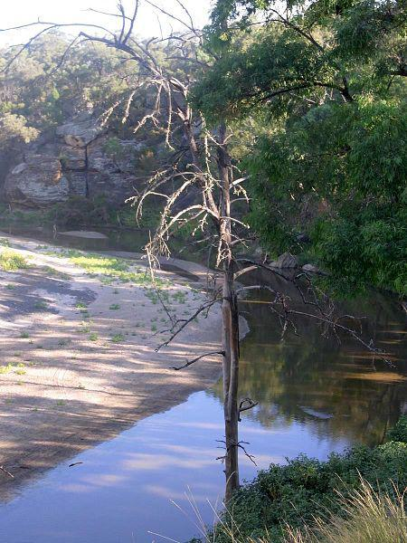

Generated Question - Do the Darling River and Goulburn River both flow within the same Australian state and contribute to different river systems?

Generated Answer - Yes, both flow in New South Wales but belong to different river catchments.

--- Entry for custom_id: d5c6342e0dba11ecb1e81171463288e9 ---

Image Source 1 -



Caption for image source 1: Vauxhall Velox PA estate ca 1959 Vauxhall Velox PA estate / wagon at Classic Car Show in Hertfordshire.

Image Source 2 -

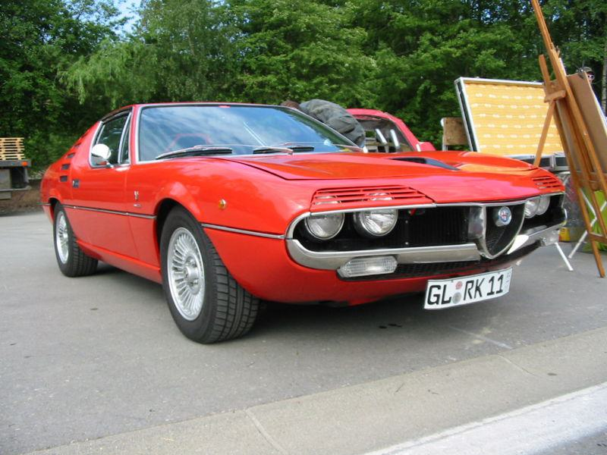

Caption for image source 2: Alfa Romeo Montreal.

Example Question - "Are the headlights on the Vauxhall Velox PA estate a different shape than the headlights on the Alfa Romeo Montreal?"

Example Answer - "No, the headlights on the Vauxhall Velox PA estate are not a different shape than the headlights on the Alfa Romeo Montreal."

Additional Text Source 1 - In its day, its best-known configuration was the Vauxhall Velox (velox, veloc- being Latin for "swift"/"fleet" and the source of English velocity) standard 4-seater with open tourer body. Vauxhall's own description was the 30–98 hp Vauxhall-Velox sporting car. (from: Vauxhall 30-98)

Generated Question - Considering the Vauxhall Velox PA estate and the Alfa Romeo Montreal, which car is more likely named to emphasize speed?

Generated Answer - The Vauxhall Velox PA estate is named to emphasize speed, as "Velox" means swift or fleet.

--- Entry for custom_id: d5cc11aa0dba11ecb1e81171463288e9 ---

Image Source 1 -

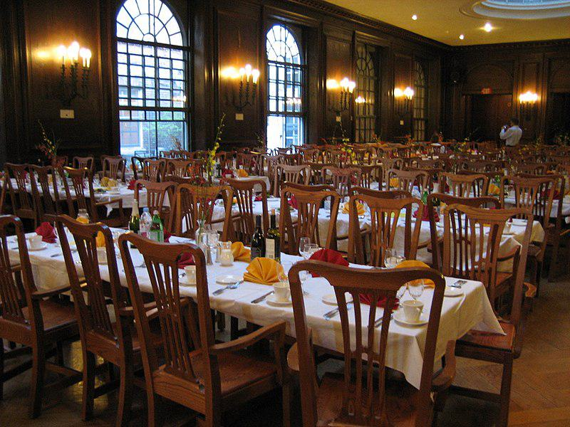

Caption for image source 1: Adams House Dining Hall.

Example Question - "What is the color of the table cloth in the Adams House Dining hall?"

Example Answer - "At the Adams House Dining hall, the table cloth is white."

Additional Text Source 1 - An Adams win would result in a return of the gong, continued use of "Pfadams House" with Pfoho becoming "Orzheimer House", though Adams generously offered to supply the rival library with a copy of "Hooked on Phonics." An Adams win would also grant the Pfoho "colonists" dining hall privileges at Adams House. (from: Pforzheimer House)

Generated Question - Would a win by Adams allow Pforzheimer House residents to dine in the Adams House Dining Hall shown in the image?

Generated Answer - Yes, an Adams win would grant Pforzheimer House residents dining privileges at Adams House.

--- Entry for custom_id: d5c606980dba11ecb1e81171463288e9 ---

Image Source 1 -

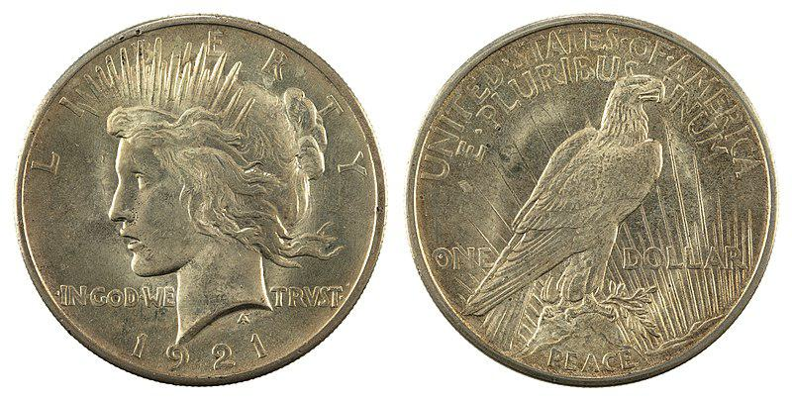

Caption for image source 1: NNC-US-1921-1$-Peace dollar JN2015-6706-07.

Image Source 2 -



Caption for image source 2: 1879S Morgan Dollar NGC MS67plus Reverse.png The reverse of the Morgan silver dollar..

Example Question - "What is different about the "In God We Trust" on the 1921 Peace dollar and the 1879 Morgan silver dollar?"

Example Answer - "In God We Trust on the 1921 Peace dollar and the 1879 Morgan silver dollar are in different fonts."

Additional Text Source 1 - The Peace dollar's lettering tended to strike indistinctly, and Burdette suggests that the new chief engraver, John R. Sinnock (who succeeded Morgan after his death in 1925), may have begun work in the middle of the motto "In God We Trust", and for reasons unknown, only the one word was boldened. (from: Peace dollar)

Generated Question - How does the placement of "In God We Trust" differ between the 1921 Peace dollar and the 1879 Morgan silver dollar?

Generated Answer - On the Peace dollar, it is split on the front, while on the Morgan dollar, it is centered on the back.

--- Entry for custom_id: d5cb32440dba11ecb1e81171463288e9 ---

Image Source 1 -



Caption for image source 1: Chaetodon ulietensis.

Image Source 2 -

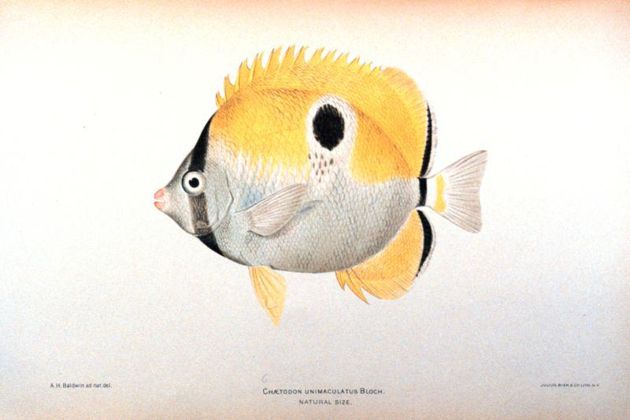

Caption for image source 2: Chaetodon unimaculatus.

Example Question - "What do both the Chaetodon unimaculatus and the Chaetodon ulietensis have running vertically across their eye?"

Example Answer - "Both fish have a black stripe running vertically across their eyes."

Additional Text Source 1 - Chaetodon ulietensis is often found singly or in pairs on coral-rich reef systems, foraging on sessile invertebrates and algae. It is not a territorial species that freely grazes throughout a wide range within reefs, lagoons and harbors, and every now and then large groups congregate at rich feeding spots. (from: Chaetodon ulietensis)

Generated Question - Do both Chaetodon ulietensis and Chaetodon unimaculatus exhibit solitary or group behavior while feeding?

Generated Answer - Chaetodon ulietensis can be solitary or in groups, while Chaetodon unimaculatus behavior is not specified.

--- Entry for custom_id: d5db3df60dba11ecb1e81171463288e9 ---

Example Question - The photoelectric effect is the what, a variety of which are called secondary electrons, when electromagnetic radiation, such as light, hits a material?

Example Answer - Emission of electrons

Image Source 1 -

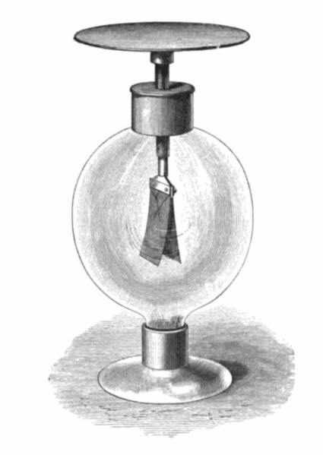

Generated Question - How does the gold leaf electroscope demonstrate the emission of electrons in the photoelectric effect compared to secondary electron emission?

Generated Answer - The electroscope discharges by electron emission when high-frequency light hits it, unlike secondary emission caused by charged particles.